STUDY PAPER IN SUPPORT OF:

Seeking hope amid despair in Central America:
the challenges of the faithful
(2022)

TABLE OF CONTENTS

- Introduction to the Study Guide
- Summary Observations and Analysis: Listening to our Church Partners in Five Countries:
Northern Triangle (Honduras, El Salvador, Guatemala), and Southern Central America (Nicaragua & Costa Rica) and Acronyms used in report
- Theological Reflections
- Historical Context: What changed in Central America from 1983 to 2019?
- Team Method, Strategy, and Visits to Central America
- Maps, Charts and Tables
- Bibliography

Section I. Introduction to the Study Guide

This study paper aims to let the reader share some of the key experiences of the Central America Study Group in the two phases of our study, and in our reflection on those experiences. In the first phase of our work, we traveled in Central America (See Illustration 1) in 2019 for a wide range of visits arranged by our mission co-workers in that region. In the second phase, in 2021, we used Zoom video-conference technology to re-visit some of our key 2019 interlocutors and also to interview some new sources. You will find more detail of the team’s approach in Section V of this document. As a briefer introduction to your reading, we here present the key questions that shaped our work.

In 2019, we sent an introductory letter to each of our guests to undergird our hope to listen to their reflections and testimonies. The key questions that surfaced in most of our conversations centered on the following:

- What has changed since the wars in Central America ended more than two decades ago? How has life changed for better or worse in recent time?
- Why are Central Americans now leaving their homes, risking their lives on dangerous journeys to other countries?
- Are you hopeful for the future of your country? We asked our interviewees to reflect on their hopes for their future of their country, both politically, economically and socially. Do they feel safe at home and at work? Do local and national authorities uphold the law?
- How have churches, religious groups, and other grassroots organizations accompanied family members left behind and responded to the particular needs of returnees?
- What have you learned about the role of gender-based violence in decisions to migrate, and from the experience of victims of gender-based violence?
- How has your region experienced climate change? How adequate are water resources and sustainable agricultural practices to meet your needs and those of your neighbors?
- How do the Bible studies, sermons, prayers and testimonies shared in your churches reflect on these challenges? What theological insights have emerged as you have reflected together on the current situation both at home and abroad?
In the period between those 2019 visits and our 2021 video interviews, the challenges we had discussed in our visits continued, but much had changed. Central America suffered profound impacts from the Covid-19 pandemic, from the back-to-back hurricanes, Eta and Iota, in November 2020, and from moves by political leadership toward autocracy and toward resisting anti-corruption efforts. Our 2021 interviews focused on the effects of those changes, and on how our church partners and other civil-society organizations were responding, and on how we can best support them.

A key focus throughout our study has been “hope” – not just the nature of hopes for the future, but how and where – and if – hope can be found in situations that engender despair. In the face of despair, there is a desperate need for hope that motivates action toward building beloved community. “Seeking hope amid despair.” That is, indeed, the challenge of the faithful in Central America.

Section II. Listening to our Church Partners

Summary Observations and Analysis
Honduras, El Salvador, Guatemala in June 2019
Nicaragua and Costa Rica in October 2019
Virtual Interviews in June and July 2021

NORTHERN CENTRAL AMERICA
Honduras –
What we heard and saw in Honduras shaped our experiences in Central America. We landed in Honduras in the midst of nationwide protests emanating from the presidential elections of 2017. Many concluded that the elections were fraudulent and President Juan Orlando Hernández’s alleged connections with drug trafficking have led some to label Honduras a narco-state, especially after his brother’s conviction on drug trafficking charges in New York. At the time of our visit, activists led by teachers and health care providers had formed the Platform for Health and Education and were taking direct action by blocking some of the main transportation arteries in hopes of pressuring the president to resign under the specter of corruption. Some argued that Hernández remained in power largely with US backing, until he left office after his second term in January 2022. Juan Antonio “Tony” Hernández was sentenced to life in prison in March of 2021, and President Hernández continued to deny his involvement with the drug trade in a September speech to the United Nations in anticipation of general elections to be held in November.

While we did not actually see the protests, the tenor of our visit was shaped by what was happening in various parts of the country that seemed to coalesce around the idea of forced migration. Perhaps most poignant was the evening when we shared a meal with members of our partner denomination, the Misión Evangélica Presbiteriana de Honduras (Evangelical Presbyterian Mission of Honduras). We heard stories of fraud as people with plans to migrate were made false promises for the arrangements, extortion as one woman’s husband left to go to the United States and was kidnapped near the border, rape and other kinds of violation of women on the migration route through Mexico, and return migration as people gave up and returned to face the same few opportunities that led them to contemplate the journey in the first place.

We did encounter hope in the form of the Mennonite Commission of Social Action (Comisión de Acción Social Menonita, CASM), which works throughout Honduras on local development projects focused on the most vulnerable populations, including youth in neighborhoods where gang violence is prevalent. Beyond day-to-day issues of engaging with people struggling to construct a dignified life, representatives from CASM also have traveled with the migrant caravans that have traversed Guatemala and Mexico on the way to the United States. CASM sees this ministry of accompaniment—and the caravans themselves—as a way of decreasing the vulnerability of individuals traveling alone or in small groups on the journey northward in the context of what is increasingly referred to as forced migration. in search of a dignified life. Our July 2021 update with CASM confirmed that the exodus continues (See Illustration 2), and has increased, in the aftermath of hurricanes destroying homes and crops, of COVID’s economic impact, a collapsing medical system, and of relief funds lost to corruption. Those trying to migrate, however, now meet with forceful police presence at Guatemala’s southern border, and deportation from Mexico or the US, even as their own government (CASM told us) labels them as ‘criminals.’

We experienced hope, too, but also despair, in our continuing discussion with the Misión Evangélica Presbiteriana. In 2019, they described for us the descent of Honduras from being the ‘granary of Central America’ 40 years ago to the poverty that assails it now. For many – including church members – there seems no option but to migrate. In 2019 they talked of gratitude that US churches have helped them buy land, build churches, provide educational scholarships, and organize medical missions. In 2021 they described how, as the country locked down due to COVID, US financial support from US partners had allowed them to run new medical missions using purely Honduran personnel, and to take food and medical aid to communities devastated by hurricanes Eta and Iota. But even as Presbytery moderator Rev. Juan Rodas and his son, elder Alex Rodas, talked of these achievements, they also talked of the despair at so much death and suffering, and their inability to respond to all the demands placed on them. There were tears by all on that call, in a way that really brought home the difficulty of bringing hope out of despair in much of Central America.

In 2019, a representative of the Jesuit-run Equipo de Reflexión, Investigación, y Comunicación (ERIC) and the Catholic Radio Progreso labeled the period since 2009 as a period of “abnormal democracy.” Regular elections give apparent legitimacy to a system rife with “structural cynicism” and rampant violations of human rights. These include assassinations of activists, documented by the Interamerican Commission on Human Rights of the Organization of American States (CIDH-OAS). Our visit to the Mission to Support the Fight against Corruption and Impunity in Honduras (MACCIH), an international oversight commission supported by the OAS and similar in vision to the International Commission against Impunity in Guatemala (CICIG), left us impressed by the organization’s commitment to strengthening the local capacity to identify and dismantle networks of corruption and hold state institutions accountable in the face of what can only be called a crisis of governmentality in Honduras. This crisis was brought into clearer focus when MACCIH’s mandate was not renewed by the Juan Orlando Hernández administration, and its mandate expired in January 2020. The Consejo Nacional Anti-Corrupción attempts to continue the work, but cases rarely proceed to prosecution, and those denouncing corruption face threats or even assassination. The scope for corruption is only increased by the Honduran government’s establishment in a 2013 law of ZEDEs – Economic Development and Employment Zones – “charter cities” or “private cities” which provide ‘legislative, administrative, judicial, and financial autonomy to investors for a wide range of territorial ventures, including urban development and resource extraction.’

In 2010, the PCUSA General Assembly recognized the 2009 Honduran military action that removed President Manuel Zelaya from office as effectively a coup and protested its speedy acceptance by the Obama-era State Department. While it is a mistake to attribute too much power in the region to the United States, in this case one can argue that diplomatic entanglement amounted to a soft form of intervention, tipping the scales against the will of the poorer majority of Hondurans. In many ways, this recent case reflects the linkage between US political and economic agendas throughout Central America. Simply viewing the pervasiveness of US-based transnational companies in virtually every sector of Central American economic life helps one understand how much the entire region lacks economic independence.

El Salvador –
In certain ways, El Salvador offered more of what we had experienced in Honduras. We were told again that people migrated because they simply had no choice. Katherine Andrade, a representative of the Catholic Relief Services outlined four key issues facing the nation: 1) economic opportunity; 2) violence; 3) the depletion of resources and the disasters (including floods, earthquakes and volcanic eruptions); and 4) family reunification. Together, these issues raise concerns for citizen vulnerability and security, with the implication that the Salvadoran state is not only fragile but, in fact, absent in responding to the needs of the citizenry.

Absence of effective governance emerged as another push factor driving migration and abandonment of the country. In our 2019 visit we heard hope that the election of thirty-eight-year-old Nayib Bukele to the presidency that year might bring some positive change. This hope was based in part on his lack of association with either of the political parties that traced their roots to the adversaries during the 1980s, the government-associated ARENA party and the guerrilla-associated FMLN. Even so, no one was clear what his policies would look like in relation to the continuing gang-related violence that receives so much attention both within and outside of El Salvador. Early observations from his twitter account indicated a return some form of the mano dura or iron fist policies of the past, along with his continued refusal (at least publicly) to negotiate with the gangs in relation to the future of the country. By 2021, human rights and other groups were raising concerns about increasing authoritarian tendencies based in part on actions by the governing party in the leadup to legislative elections that gave Bukele’s Nuevas Ideas (New Ideas) party a majority of seats in the national congress. In September, Bitcoin became legal currency in El Salvador, and that was followed by a ruling from the Salvadoran supreme court, composed largely of Bukele supporters after the parliament removed several members in May, cleared the way for a possible second presidential term in 2024. Legal and other observers have argued that this ruling violates the constitution. While Bukele does seem to enjoy some popular support, there is rising concern about the state of democracy in El Salvador, a concern fueled when his profile on Twitter was changed to “El Dictador más cool del mundo mundial” (“the most cool dictator in the world.”)

As indicated in the discussion of Honduras, gang activity is now embedded in the social reality of all three countries of the northern region of Central America. Reflection on gangs in El Salvador demonstrates the importance of the systemic analysis of social problems and how such analysis reveals the complicated transnational aspects of US-El Salvadoran relations, especially since the 1980s. Many studies highlight the origins of Salvadoran street gangs among Salvadoran exiles in Los Angeles as a result of the violence of the revolution and US support for government counterinsurgency efforts. In effect, deporting young men who had migrated to Los Angeles as children or young adolescents during the war had a profound impact on people who barely knew the culture of their birthplace. Without work or a sense of belonging, the gangs operated as havens for the men who experienced what some have referred to as a sense of deterritorialization following their deportation. Related to the theme of gang violence was the theme of the criminalization of youth, a prevalent theme that appeared in both Honduras and El Salvador at different moments in our conversations.

Family reunification and the reintegration of returnees into Salvadoran society was a major theme of our discussion with the Salvadoran Institute of the Migrant (INSAMI), which seeks to respond to the “human trauma” of a “double separation” for those who had long lived in the United States and then been forced to return (See Illustration 3). The first separation was the separation from their family during the initial journey, while the second had to do with the separation from the lives they had established in over two decades of living and working outside of El Salvador. Those who work at INSAMI see their presence providing a “voice of encouragement” (“voz de alento”) or a type of “cure for the soul” (“cura del alma”). Among other services, they provide health examinations for the recently returned since many will have untreated conditions, perhaps for years, depending upon their history in the US.

The larger concerns are that returnees should be neither revictimized nor stigmatized as they seek to reestablish themselves in El Salvador. One act of bridge-building is the celebration of Thanksgiving, which became a tradition for some who spent most of their lives in US culture. It may be a small, and for some a contradictory, gesture but the idea is that returnees have a tradition of their own to share, and INSAMI recognizes this as an act of dignity that can be shared with family and friends in recognition that the celebration was learned with family on the other side of the US border. Beyond direct attention to returnees, INSAMI also works to draw attention to the inhumane aspects of US migration policy, including the record deportations and resulting family separations under both the Obama and Trump administrations—frequently justified by minor violations of US law on the part of the deportees.

Leaders from the Reformed Calvinist Church of El Salvador (Iglesia Reformada Calvinista de El SalvadorIRCES) and the Joining Hands Network Association of El Salvador (ARUMES) were our primary interlocutors in El Salvador in 2019, with continued conversation with IRCES in 2021. They convincingly described the frayed social fabric of El Salvador and, in our first encounter, provided some of the more hopeful stances we heard on our journey. The message from these colleagues was a liberationist message of accompaniment alongside those who struggle to persevere in the face of marginality and the lack of economic opportunity. Nevertheless, it is a message born from a clear-eyed vision of the difficulties of life in El Salvador. Some of our partners themselves had experienced threats or lost family members either to death or migration. In 2019, after attending a morning worship service in San Salvador, we spent an afternoon learning about the church’s attempt to respond to what was referred to as the social problem of 30 years of insecurity—not only from gangs but also from government ineptitude. National security colloquially understood is not the issue. We were presented with a profoundly analytical approach to social problems, resistance to governmental absence and impunity, as well as an integrated focus on development and environmental concerns that itself has been forged in activism focused on creating a “culture of living together” (“cultura de convivencia”). Our 2021 conversation demonstrated that analysis, response, and stubborn hope continue even in the face of increasing challenges to daily life.

Multiple social challenges emerged in the narrative of our church partners. The privatization of both education and health was raised as a problem, in addition to the need for integrated approaches for addressing violence against women, the treatment of those with LGBTQ+ identities, and rampant teenage pregnancy. On the environmental front, ARUMES gives attention to access to water resources that have sometimes been syphoned off for the use of transnational corporations linked to the bottled drink industry or mining activities. Agroecological concerns are central to the work of the network, which is directed toward transforming thought process of those who are confronted with the task of attacking such problems. Agricultural projects that face the effects of climate changes are also a key part of IRCES’s work to help people thrive in place.

The liberationist tone from the representatives of the Reformed Calvinist Church was reinforced by a representative of representative of Cristosal (literally, “Christ-salt”), a human rights organization with links to the Episcopal community in both countries. Many people in El Salvador live out the trauma from internal displacement resulting from fleeing attempts at extortion. In places where milk and honey do not flow, where incarceration rarely means rehabilitation, and where a lack of security and opportunity push people away, what would it mean to create a place where people could imagine NOT leaving?

Guatemala –
Finally, in the first of our two 2019 study tours, we arrived in Guatemala, by far the largest country in Central America in terms of population and absolute economic development. At the same time, the aggregate indicators of wellbeing place the country in the same category as its neighbors in terms of poverty, and the inequities between the wealthiest Guatemalans and those on the lower end of the socioeconomic scale is one of the starkest in the Americas. This is especially true from the vantage point of the Maya population that is composed of some 22 linguistic communities and makes up some 40 to 50 percent of the national population. Migration from Guatemala is prevalent not only from the predominantly Maya highlands in the western part of the country but also from the eastern lowlands that adjoins Honduras and El Salvador. At the regional level, migrants from both Honduras and El Salvador also must pass through Guatemala on their journey northward. This geographic reality made Guatemala a strategic country in the Trump administration’s effort to clamp down on migration by declaring Guatemala a “Third Safe Country” from which migrants could make asylum claims. Although this agreement, and similar ones with Honduras and El Salvador, was suspended by President Biden’s administration less than a month into his term in office, the US continues to encourage and support Guatemala’s use of force to prevent migrants passing through its territory en route to the US border.

Migration was again a major theme in Guatemala, and we traveled to the municipio of San Juan Ostuncalco in the highlands west of Guatemala City, a region that has long sent migrants to several areas of the Midwest and to the Baltimore-Washington, D. C. area. It is a predominantly Maya community (over 90 percent) whose residents speak the Mam language. We wanted to have a view of both successful and not-so-successful attempts at migration from a rural area so that our work might include firsthand accounts of the migratory experience shaped by the learnings of those who had made the journey---and of others who had remained at home.

Over a meal, we listened for two hours and heard five stories of sometimes harrowing attempts to cross the border, including of a young minor woman who was separated from a group at the border but sent to live with relatives in Indiana. One young man in his late 20s had worked in the States, saved money, and returned home to start a couple of small businesses and continue his working in agriculture. He thought that the $15,000 it cost to make the journey, the three attempts to cross the border, and the six years he spent in Maryland had been worth it—because of the difficulties of making a living in Guatemala and the opportunities opened up by returning home with savings. Another woman talked of nearly losing traveling companions in crossing the Rio Grande and the difficult situations in detention after having made the decision to leave children behind, even praying that God would take the image of her children out of her mind so that she could strengthen herself for the journey. To some degree after nearly three years away, she thought that she had found a “land of blessing,” even using the image a place flowing with milk and honey—in contrast to so much of the Central American reality we encountered and that our partners live. Yet another woman spoke of living with debt after the two failed crossing attempts of her sons of 23 and 19 years of age, while an older man talked of his own failed attempt at crossing the border 14 years ago, of what it was like to cry as he was held in detention for simply looking for work to provide bread for his children. He was aroused at 2:00 in the morning so that he could have a court date and be put on a flight back to Guatemala. Had he missed the date, he would have been held even longer. He thanked us for listening, as people from the United States. “Dios es grande, y la historia es triste” (God is great and history is sad”), he told us. Then he reminded us that Guatemalans have the will to work to give something to their own.

The bookend to this 2019 experience was a visit to the Guatemalan Episcopal Conference’s Pastoral de Movilidad Humana (the Pastoral Office of Human Mobility) and its executive secretary, Father Juan Luis Carvajal, a Scalabrinian priest from Mexico. The name, Pastoral Office of Human Mobility, may not translate gracefully into English, but the image on their flyer is of Mary and Joseph moving with the Holy Infant into exile. There is no more powerful image for confronting us with the conditions that send people on the road into an uncertain future. The office seeks to provide dignity to those who are found in “situations of migration, refuge, or trafficking,” and our conversation focused on the sweep of migration issues confronting the region and the articulation of a theology of migration that would strengthen the Church’s work on the right to migrate.

That language might seem strong for some North Americans, but we note here that the right to migrate and return to one’s home country is enshrined in the Universal Declaration of Human Rights, while the 1951 Refugee Convention and the companion 1967 Protocol Relating to the UN Convention on the Status of Refugees guides the thinking surrounding the right to apply for asylum and the access to territory from which to do so. The Office of Human Mobility works on these issues by documenting the breadth of the Central American migration crisis and by providing houses of attention to migrants throughout Mesoamerica. Father Carbajal said, “We are like salmon swimming upstream. All of the countries are aligning themselves with antimigratory polices, and these are driven from up there.” “Up there” clearly meant the United States.

This conversation also connected with the discussion with Cristosal in El Salvador in which we heard of negotiations in progress to end Temporary Protected Status and repatriate people who had been granted humanitarian relief to live and work in the United States because of natural disasters or war. While TPS was, in September 2021, extended through 2022 for several countries including El Salvador, Honduras and Nicaragua, TPS has not been granted for Guatemala. Father Carvajal, in his theological reflection, reminded us of the importance of historical memory, and of the Hebrew scriptures that call us to a “spirituality of welcome, of hospitality.” He also lamented the divisions among Christians that keep us from lifting up “a clear voice, unanimous and united in order to defend our own people” even if that means taking a stand against governmental policies that violate our ethics as Christians.

This ethical stance in turn reminds us that migration is symptomatic of other ills that have deep roots in Central American society regardless of how exacerbated they may be from the outside. These ills were reflected when we spent a morning with the Stories of Faith Women’s Theatre Collective. Intentionally multiethnic, the Collective is a group of Maya and Ladina Presbyterians formed 15 years ago to work together on a common project across lines of racism and discrimination that have permeated social relations for centuries. The women produce sociodramas that bring to life common life experiences that can be reflected upon as groups confront specific issues in their personal lives and communities. Knowing that we had an interest in environmental issues, the women performed two dramas for us that linked issues of environmental degradation and migration. Family separation related to forced migration appeared in the dramas and our discussion afterward, as did issues of maintaining water resources in the face of deforestation and corporate greed surrounding the growth in African Palm plantations and so-called megaprojects focused on development infrastructure that are often initiated without consulting the communities that might be negatively impacted by them.

One of the women noted how the Collective functions as therapy for her in a context where there is often little optimism, and another lamented that their own denomination didn’t have the moral foundation necessary to respond to migration. This bears further reflection as a critique our own understanding of partnership and mutuality in mission relationships that all too often have created conditions of dependency rather than empowerment in the context of so many issues that transcend national borders. The work of the Collective calls us again to reflect on what it means to defend life in the face of physical and spiritual deserts of all kinds.

Guatemala’s future is unclear as we conclude this report. The social problems are as deep as in the other countries we visited, yet because of its geographic location, one might argue that the country operates as a funnel that opens the entire region of Central America to the North as people continue to flee living conditions that they perceive as impossible to bear. The litany of internal struggles familiar: threats and violence directed toward environmental and indigenous activists who have taken on corporate and government interests in mining activity; difficulties in mobilizing for women’s reproductive health, including the right to abortion, the pervasive reality of domestic abuse, and the fear of femicide; discrimination against those with “different sexualities.”

We heard in a 2021 conversation with Rev. Delia Leal, Baptist minister and former (long-term) employee of CEDEPCA (the Protestant Center for Pastoral Studies in Central America) that COVID lockdowns have unleashed a ‘twin pandemic’ of increased domestic violence, a pandemic not unique to Guatemala. Those who speak out and act against gender-based discrimination and violence find themselves under attack; Rev. Leal faces trumped-up legal charges in an attempt to shut down her work and her strong voice on behalf of victims of domestic and sexual violence. At the governmental level, corruption and the specter of a narco-kleptocracy are on the minds of many, while there seem to be few plans to address the profound social inequality noted earlier. President Alejandro Giammattei of the new VAMOS (“Let’s Go”) party is a former doctor and conservative businessman, as well as the former head of the Guatemalan penitentiary system, with a number of ties to the Guatemalan military. One perennial fear since the end of the country’s civil conflict in 1996 is the influence of the military in internal affairs.

Giammattei’s victory in the second round of the 2019 elections was said to be a victory for abstentions in the light of the fragility of the Guatemalan state. His administration has been harshly criticized for corruption surrounding access to vaccines for COVID-19. The health ministry has approved the use of vaccines from several countries, but there has been difficulty in both attaining them and distributing them within Guatemala. The result was initially one of the lowest vaccination rates in Latin America. There remains space for action in response in relation to corruption and insufficient attention to the needs of the citizenry, but it appears to have diminished somewhat in the following the demise of the CICIG (the International Commission Against Impunity in Guatemala) in the last year of the presidency of Jimmy Morales, also in 2019, and the threat of impunity in relation to human rights violations hangs in the air. The Giammattei administration declared partial or complete states of calamity several times during 2021. These declarations restricted entry to the country and limited public gatherings, ostensibly with the goal of detaining the spread of COVID. On at least two occasions, the congress has rejected the executive orders, and in some cases, the declarations were interpreted as attempts to quell dissent among the populace in response to the government’s ineffectual response to the virus and other social concerns. The judicial system itself is under stress, as seen in the sacking of the anti-corruption prosecutor Juan Francisco Sandoval by the attorney general’s office in July of 2021.

In the face of this uncertainty, we are thrown back on the perspective of the we heard at near the end of our conversation at the Pastoral of Human Mobility, the idea that in looking for alternatives, “We have many theological elements in order to extend hospitality and the defense of human rights from a church on the road. . . For us even the Eucharist is manna for the one who walks.” And this comes from the “God of the tent, who doesn’t sit or stay still but who walks with the one who walks.”

SOUTHERN CENTRAL AMERICA
Nicaragua
Nicaragua is every bit as troubled as any Northern Triangle country, but its issues are less visible in the US, simply because most of those emigrating from Nicaragua have until recently tended to travel to Costa Rica, with fewer seeking asylum (or otherwise trying to enter) the US. That said, Nicaraguans are fleeing in substantial numbers. It was reported in October 2019 that “since April 2018, over 83,700 Nicaraguans asked for asylum in other nations, roughly 68,000 of them in Costa Rica.” The numbers fleeing are probably higher, as not all will formally apply for asylum. By 2021, increasing numbers of Nicaraguans were making their way to the US-Mexico border, more than 19,300 in the fiscal year beginning on 1 October 2020, compared with the previous high in 2019 when the number was 13,000.

What is causing this flight? As we heard at CENIDH, the Nicaraguan Center for Human Rights, while some are economic migrants, the majority are fleeing violence rooted in the government’s response to April 2018 anti-government uprisings. (And the two are not unrelated, as the economy has collapsed in the aftermath of April 2018.) Were those uprisings a justifiable response to government policies, or were they a (possibly US-backed) coup attempt? Both points of view are evident in Nicaragua and in the US. Our study team listened to voices on both sides, and we found it difficult to deny the profound dissatisfaction which the government of President Daniel Ortega has aroused. Controversy surrounding the detention of several presumptive opponents in the presidential elections of November of 2021 heightened this tension. (One of our 2019 interlocutors was among those so detained.)

Daniel Ortega first led the country beginning in 1979 when the Somoza dictatorship was overthrown by the FSLN (Sandinista National Liberation Front). What followed was the “Contra War” – with US-backed fighters based in Honduras seeking to overthrow the FSLN, which was, meanwhile, bringing to Nicaragua significant social progress in arenas such as education, poverty-reduction, health and healthcare. Ortega lost the 1990 elections to Violeta Chamorro whose government installed a more neoliberal economic system. By the end of the decade, a so-called “pact” between Ortega and then president Arnoldo Alemán (1997-2000) allowed for a type of power-sharing between the Sandinistas and the Liberal Party and reduced the absolute percentage of votes need to accede to the presidency following the first round of an election cycle. Some argue that this helped pave the way for Ortega to win back the presidency in 2006. When he took power in 2007, he was (and is) still seen by many as a hero of the Sandinista revolution. However, with his wife, Rosario Murrillo, as his vice-president, he is seen by many as increasingly taking over Nicaragua’s state institutions, selling out Nicaragua’s natural resources, criminalizing his opponents, and profiting personally in the process.

A major example of the sell-out of natural resources came in 2013, with the “Law 84” grant of an isthmus-crossing canal concession to a private Chinese firm. That Chinese firm has since gone into bankruptcy, but in the meantime, opposition by the Anti-canal Campesino Movement (concerned about ‘grabs’ of both land and water) was widely supported by, for instance, student groups. Then, on April 3, 2018, a wildfire broke out in the Indio Maiz Biological Reserve in southeast Nicaragua. Inadequate government response to the fire again triggered student-led protests. And on April 18, 2018 students once again took to the streets to protest changes to the social security law that, in particular, threatened the pensions of their elders.

We heard many (at times conflicting) accounts of the aftermath to April 18. Even the government’s own Truth Commission admits to 275 killed in uprisings and government response between April 18, 2018, and July 15, 2019. Officials at the political section of the US Embassy (which we visited the same day) reported about 325 deaths, and we heard from several groups who thought that the numbers were much higher, given the level of fear of reporting such deaths, and that some had been categorized as ‘heart attacks’ or something similar.

One particularly moving account of April 18 and its aftermath came from Father José Idiaquez (“Father Chepe”), Jesuit priest and rector of the Central American University (UCA) in Managua from which some of the student demonstrators came. When we visited him on October 1, 2019, Father Chepe talked of the student support for campesinos in their struggle against the canal, and against targeted assassinations. (He reported two to four campesinos and indigenous land-defenders killed each day, with northern Nicaragua, in particular, described as a “river of blood.”) Students were part of the April 18 demonstrations, and went on strike on April 19th. The police and military response was fierce, with the violence reaching its peak on May 30th, ironically “Día de los Madres” (Mothers’ Day), when military snipers were stationed on the roof of a stadium overlooking the UCA campus and killed 20 students in less than an hour (adding to the 64 already killed in the violence). The snipers even shot the tires from fire trucks being used as ambulances. Many students were imprisoned and tortured. And mothers did not dare to attend their children’s funerals. The government has publicly claimed that UCA is part of a coup d’état, and Father Chepe is receiving death threats. In his words, “We are living under terror.”

With that as background, it is particularly remarkable that UCA offered space and support for The Museum of Memory against Impunity set up by the Association of the Mothers of April (AMA). Our October 1st 2019 visit coincided with the first day of operation, and this display of the history of uprising and oppression, and of personal effects of victims, with all the docents being family members of victims, was perhaps the most moving experience of our time in Nicaragua.

Another aspect of the post-April-2018 “undeclared state of emergency” has been the closure of NGOs and the repression of press freedom. The (independent) Nicaragua Center for Human Rights (CENIDH) is but one example of many organizations who have had their legal status revoked (on the 12th of December 2018), with their offices raided, their bank accounts frozen, and their team-members threatened. Another wave of NGO closures came in August of 2021. Meanwhile, on the press front, numerous media organizations have been either taken over or closed down, and journalists have even been attacked. Armando Pinosa, and independent journalist with whom we met in Costa Rica, reported that in January 2019, when he was in a safe house en route to exile, there was a police raid on his home, with his family threatened, and his daughter taken and imprisoned for 6 months. Despite this, he feels the need to speak out, and has joined a group of about 50 “Independent Journalists of Nicaragua in Costa Rica.”

Are there attempts to find a peaceful conclusion to all of this? We met with leaders of the opposition “Civic Alliance” which formed specifically in order to take the opposition lead for talks with the Ortega government – talks that have served primarily to show the government’s reluctance to make any real progress towards peace and reconciliation. The group brings together some strange bedfellows, from high-powered business leaders to former Sandinista guerrillas. The former grouping had been allied with Ortega’s pro-business policies of recent years, until the current turmoil ruined the economy. The difficulty of making progress was highlighted in 2019 by the need for one of those leaders to move from house to house to try to avoid detention, and the fact that in 2021 another of those leaders, Juan Sebastián Chamorro, was among the potential presidential candidates detained by the Ortega-Murrillo administration.

The Ortega government still has its supporters, but many are radically disillusioned. We talked with two former Sandinista guerrillas, one (Sandra) now a Civic Alliance leader in Nicaragua, and the other (Danilo) now an economics professor at the University of Costa Rica. In the words of Sandra: “In the 1980s I loved the revolution. I’ve always been Sandinista, and I’m not ashamed. But April 18 woke me. We’ve lost our way. I had to go with ‘the people’ – my ideology was never more important than people and nation. So now I’m accused of being a traitor.” She pointed out that Sandinistas trying to leave the movement are in danger. “I’ve not been home for a year and a half, and my home has been vandalized by paramilitary groups.” Danilo’s message was similar: “My history is as a Sandinista guerrilla, but what is happening now is a betrayal of the dead from that struggle.”

Where does the church stand in all this? Both Roman Catholics and Protestants are deeply divided. The institutional Roman Catholic Church has mostly come out in support of the opposition, even sheltering the hunger-striking mothers of political prisoners. And yet it was a group of breakaway Catholic Christian Base Communities who led a raid on Managua’s Metropolitan Cathedral in protest of the institutional church’s support for Ortega’s opponents. On September 29th, we met with Rafael Valdez and his wife, Carolina, head of “Families of God” base community, and heard their love for their people and their passionate defense of both their base-community work and their Sandinista alliance. It was Rafael’s brother, Tomás, who (with Rafael) later led the November raid on the cathedral.

The Protestant community is no less divided. Having lost the support of the Roman Catholic Church, President Ortega has made alliance with the more conservative end of the Protestant spectrum. When we visited CEPAD, an ecumenical (Protestant) group providing a wide range of grass-roots theological education and serving broad social needs, we heard a strong desire to stay politically neutral, but also indications of how difficult that was at both the personal and institutional level. At both CEPAD and CIEETS (the Inter-Church Center for Theological and Social Studies), we heard concern at the increasingly neo-Pentecostal and ‘prosperity gospel’ turn among Nicaragua’s Protestant. One sign of that was the summer visit to Ortega by “The Trump Cabinet’s Bible teacher,” Ralph Drollinger, head of the highly conservative Capitol Ministries. Another would be the increasingly homophobic and misogynistic tone of Nicaraguan political rhetoric. At CIEETS, we heard that (as elsewhere in Central America), so-called “gender ideology” is being broadly condemned, and CIEETS’s more open stance means that they are receiving threats both as an institution and individually. In 2021, they also talked of fear that prevents many from speaking out against the government: they talked of “El Silencio que Grita” – the silence that screams.

How should we as church in the USA respond? One answer is to be careful who we support! And yes, we heard from various PCUSA partners of their financial struggles, and their desire not just for financial support but also for prayer. CEPAD in particular asked for physical accompaniment – that church delegation visits, which have dwindled almost to nothing – should resume. But perhaps the major ‘ask’ was that the situation in Nicaragua should be better known and understood. When asked for the Bible message that he found most helpful in the current situation, UCA’s Father Chepe replied that it was John 8:32 “The truth will set you free.” As Juan Sebastian Chamorro, the head of Civic Alliance, put it, “Que el mundo sepa” – “That the world should know.”

Costa Rica
Costa Rica is, in many ways, the least troubled of the five countries in Central America that were the subject of our studies. It brands itself as “the Switzerland of Central America,” with a strong emphasis on ecotourism, and adopts the national slogan “pura vida”— "pure life.” It prides itself on having abolished its army in 1948, and on being more politically progressive and democratically stable than the rest of Central America.

But all is not well in this apparent haven. The army may have been disbanded, but the police, we were told, have become militarized. Ecotourism may be thriving, but its images and slogans play up nature while ignoring the people and diverse cultures of the country. And nature itself is suffering, not least from pollution due to extensive pineapple plantations; San José has the second most polluted river in Latin America. Poverty is rife, as is sexual tourism, and the many metal-and-razor-wire-fenced houses were testimony to the fear of crime, and of “the other.” In 2021 we heard from a researcher at the University of Costa Rica that the drug trade, often thought to have bypassed Costa Rica, has now taken a firm hold, and is strongly linked to political corruption. These concerns and more were heard by the study team in 2019 when we spent several days at the UBL (Latin American Biblical University) talking to academics from both the UBL and the University of Costa Rica, as well as when we spoke with Nicaraguan exiles during our initial trip and when we renewed some of these conversations in 2021. Some of the issues we discussed were specific to Costa Rica; others were applicable to all of Central America.

One issue directly affecting Costa Rica is precisely the arrival of so many exiles from Nicaragua. Historically, Nicaraguans have often been seasonal migrants, arriving in Costa Rica to work during harvest time, and then returning home. But with well over 80,000 arriving between April 2018 and October 2019 with no way of returning, at least for the present, this country of about 5 million people is struggling. Even one of the Nicaraguan exiles pointed out to us that “we are creating a political problem for the Costa Rican government, which has low approval numbers.” Immigration controls are getting tougher, and the “Nicas” are facing significant xenophobia and discrimination, even as both they and the locals are suffering from a very high cost of living relative to other places in Central America. Locals (such as our van driver from the airport on arrival) think (and may resent) that Nicaraguans receive excellent social, medical and educational services, but the truth is that they only qualify once their application for asylum is granted, and that can take years.

Costa Rica is facing its own economic problems. As Javier Argueda, from ICADS (the Institute for Central American Development Studies) told us, while Costa Rica’s economy was thriving from 1940 to 1980, it has been in crisis ever since, with both CAFTA (Central American Free Trade Agreement) and the broader neoliberal / privatization policies of the Washington Consensus (as applied by the World Bank and IMF) exacerbating poverty in Costa Rica. Around 20 percent of the population lives on less than $2 per day, with 6 percent trying to live on less than $1 per day. The UN Human Development Index indicates that 45 percent of Costa Ricans cannot satisfy basic needs.

Costa Rica shares the same ecological and climate challenges as all of Central America, and these are heavily exacerbated by large-scale agriculture and deforestation caused by logging and other extractive industries. Drought is increasingly affecting the whole of the region, and raises a particular problem for Costa Rica’s heavy dependence on hydro-electric power.

Ecclesial challenges to the whole region are also reflected in Costa Rica. The country is Roman Catholic by Constitution, but becoming increasingly Protestant. UBL, a historically important Protestant ecumenical institution, educates students from all across Latin America and the Caribbean (70 percent are from outside Costa Rica), and its faculty are acutely aware of the trend toward neo-Pentecostal prosperity gospel preaching, which they see as cheating the people to the benefit of pastors. The university is committed to teaching more profound understandings of how to read the Bible, and of its applicabilitysocial justice.

Final reflections

In completing our work on this report, we stand in awe at the testimony of living followers of the Christ who have remained faithful to their calling despite the threat of persecution and even death over three decades in Central America. That testament of faith gave rise to the PCUSA’s first reports during the Central America crisis of the 1980s and the clarion call joined other voices in solidarity until peace broke out in the 1990s. The promise of prosperity and life without threat of war was welcome relief. Central American leaders initiated successful attempts to integrate their economies, couple them even further to larger economies in the USA, Europe and China, and literacy and longetivity increased markedly in the region as the middle classes experienced significant expansion throughout the region. Nevertheless, persistent social inequality, , natural disasters, and limited development agendas frustrated real progress in many areas. The drug wars spilled over into the northern portion of Central America, while political actors—politicians as well as leaders of street gangs and drug lords—undermined calls for transparency and accountability and turned to the darkness of corruption to reinforce control and influence. Democratic hopes and expectations for transitional justice morphed into a narco-influenced kleptocracy that was constructed on historical inequites and fragile political systems.

The number of homicides rose dramatically in El Salvador, Honduras and Guatemala by the end of the first decade of the twenty-first century, and a 2009 coup in Honduras set in motion a social decay that exacerbated authoritarian control over the political process while murders of innocents remained unprosecuted. Entire families made choices to leave home and property to risk a new start in El Norte, the USA.

That prosperity benefitted the few more than the majority, that peace did not quell the powerful from using brute force to coerce, extort and defraud, that the great economic coupling with global capitalism simultaneously produced high expectations for life and liberty and limited opportunity locally with meager wages unleashed a Central American migratory journey of tens of thousands to realize hope in a different land.

As Reformed Christians, we are neither surprised nor intimidated by complexity or ambiguity. We long for clarity and simplicity, but know deep within ourselves that the fractured, beautiful world in which we live is marked by contradiction contradiction when human beings stray from God’s best desires for the human family. On the one hand, we celebrate diversity, wholeness and freedom as clear signs of God’s presence. On the other hand, we know that we and the communities in which we live are broken, incomplete. We understand that the systems that dominate our world are subservient to sin and death. These systems feed off brokenness and seek to crush the vulnerable in our midst.

Mindful of this, here are some of the things we learned from ecumenical partners, community leaders, experts and PCUSA mission co-workers in this study:

- The US began to intervene politically, economically and militarily in Central America early in the 19th Century, often leading to dependent political and economic systems illustrated by the term “banana republics”. This legacy suggests that the US bears some responsibility for the current corruption and violence that plague the region.
- The ongoing US demand for illicit drugs has spawned an enormous, vertically integrated, brutally violent industry that kills thousands each year in Central America and corrupts governments, militaries, law enforcement and the private sector on both sides of the border. To reduce or eliminate that demand could lead to a dramatic improvement for the quality of life of our Central American neighbors.
- Important sectors of the US economy – including construction, agriculture, food processing and services – depend on the cheap, reliable, hardworking labor provided by undocumented workers, most of whom come from Mexico and Central America. Undocumented labor has become Central America’s major export.
- The current wave of gang violence in Central America has its roots in structures and tactics brought to the region by deported youth who had become part of street gangs while living in the US in the 1980s. In many regards, this particular form of violence is a direct result of US complicity in much of the violence during those years.
- Many of the Central American families and individuals that arrive on our southern border face legitimate threats to their lives or well-being in their homelands.
- The dramatic rise in the number of women and child migrants has led to chilling increases in human trafficking, an expanding illicit enterprise controlled by drug traffickers in collaboration with governments, security forces and the private sector on both sides of the border.
- Many migrants submit asylum claims based on gender-based violence. The claims are often credible and need to be given careful, compassionate consideration by immigration authorities
- Many Central American communities, mindful of the US economy’s ongoing demand for cheap labor, have implemented de facto development strategies that depend on sending their young people to the US so they can support their families by sending remittances.
- Remittances usually go directly to individual families and seldom contribute to collective development goals. Individual families often use these funds to pay for home improvements, education, healthcare, automobiles, appliances and other consumer goods. Such remittances may ease pressure on governments in Central America to provide such basic services as healthcare, transportation and education.
- Central America has witnessed a dramatic growth in religious pluralism in recent years. In recent years this growth has often resulted in religious and political practices that are antithetical to visions of justice and inclusion. Mega-church preachers – especially neo-Pentecostals – assume high-profile roles in partisan politics in the region in ways that fail to challenge inequities embedded in the status quo.
- All of these factors are complex and interconnected in ways we don’t always understand. Determining degrees of causality is far beyond the scope of this study. We do understand, however, that our response – as a church and as a nation – needs to be guided by certain principles:

- Hospitality and generosity
- Solidarity
- Justice and due process
- Advocacy for strengthening the rule of law, health, education and the well-being of the people of Central America, especially those who live on the margins of society.

We also want to look in particular at Nicaragua and its current challenges. Looking back, for many, both people of faith and political progressives, it was too easy to over romanticize the Nicaraguan Revolution. It was almost as if we wanted the Nicaraguans to live out the revolutionary vision we could never again create for our own country. Those of us from the Reformed theological tradition forgot to bring along our historic hermeneutic of suspicion. The infrastructure of the revolution insulated itself from a criticism of solidarity which could have corrected more serious errors of judgment or execution. We truly wanted to believe what Canadian singer-songwriter Brice Cockburn sang: In the flash of a moment, you’re the best of what we are.

People from most of the Central American region have experienced a state of struggle for nearly a century now. On the one hand, there is a sense of frustration and weariness in terms of how many times do we have to go through this? On the other hand, this historic experience has led to a reservoir of resilience that continues to sustain the people through the ongoing struggle to enjoy life and liberty.
Presbyterians do mission in partnership. We do so, because we have learned that our understanding of who God is, how and where God is present in all of Creation, is filtered through our specificity, our little fragment of the human experience. To be in partnership with others in God's mission - sisters and brothers from another culture, another language, another history, another experience of class and race and the created order - is to be given the gift of new eyes.
In ways we do not understand, God is present in other places in ways that are known only to people of that place. This is the oikumene - to behold the mystery of difference and know that God's presence transcends what we - in our particularity - understand God to be. Wherever we go in mission, we know that God is already there. Wherever we go, we know we will find brokenness and grace. Wherever we go, there will be structures in service to sin and death. But wherever we go, God's grace is sufficient.
To do mission in partnership is to deepen our understanding of our common calling to serve all - and most especially those on the margins of the power structures in our world - in Christ's name. To listen. To touch and be touched. To teach and be taught. To accompany. To share in solidarity. To be mutually accountable.
This is what we have learned in common service to God's mission in Central America. We are called to accompany each other in mission. We are called to uphold one another in prayer. We are called work walk together in service. We are called to denounce sin and proclaim together the Good News of Jesus Christ. “Let us run and not grow weary.”

List of Acronyms in this Report

ARENA Alianza Republicana Nacionalista (Nationalist Republican Alliance)
ARUMES Asociacion Red Uniendo Manos El Salvador (Joining Hands Network Association of El Salvador)
CASM Comisión de Acción Social Menonita (Mennonite Commission of Social Action, Honduras)
CEDEPCA Protestant Center for Pastoral Studies in Central America
CICIG Comisión Internacional Contra de Impunidad en Guatemala (International Commission against Impunity in Guatemala)
CIDH Comisión Interamericana de Derechos Humanos (Interamerican Commission on Human Rights—Organization of American States,)
CIEETS Intereclesial Center for Social and Theological Studies
ERIC Equipo de Reflexión, Investigación, y Comunicación (Reflection, Research, and Communication Team—Honduras)
FMLN Frente Farabundo Martí para Liberación Nacional (Farabundo Martí National Liberation Front)
INSAMI Instituto Salvadoreño del Migrante (Salvadoran Institute of the Migrant)
IRCES Calvinist Reformed Church of El Salvador
MACCIH Misión de Apoya en Contra de Corrupción e Impunidad en Honduras (Mission to Support the Fight against Corruption and Impunity in Honduras)

Section III. Theological Reflections

In a broken and fearful world
the Spirit gives us courage
to pray without ceasing,
to witness among all peoples to Christ as Lord and Savior,
to unmask idolatries in Church and culture,
to hear the voices of peoples long silenced,
and to work with others for justice, freedom, and peace.

This section from our own Brief Statement of Faith simultaneously grounds the work of our study team and dramatizes the PCUSA’s work as the people of God sent out to engage the world—attending to places where brokenness and fear challenge the goodness of the Creation.

As we begin the task of trying to read the landscape of Central American reality in the first two decades of the twenty-first century, we also looked back to the past, remembering that the first Presbyterian missionary in the region arrived in Guatemala in 1882. One hundred years later, the 1983 report, Adventure in Hope, provided another piece of context for our work:

The North American church cannot be the church in Central America, but it can stand with sister and brother Christians in the region as they cry out against the powers of death. It must seek to serve the God of life, justice, and mercy, the God who promises abundant life to all the world’s people. God promises and requires justice in all human relations. The Reformed tradition is firm ground on which to stand, as new choices and decisions are called for. The response we make must informs not only positions related to the polices of the United States government but our life as a church as well. (43)

All too often, we have not been attuned to the voices of people who are marginalized by systemic injustice and threats to social and psychological wellbeing emanating from complex social and political realities that are beyond the control of individual citizens. Yet, we do need to acknowledge—and confess—the role of the United States in contributing to the conditions that continue to drive people from their homes and into an uncertain future. Part of the burden of this report is to make that history known, especially as a critical component of the current debate over migration and refugee policy. We remember from our own journey the young pastor who stood before us with tears streaming down her face as she said that she couldn’t judge anyone for leaving the country. And she added, “Aqui no se puede vivir” (“It’s not possible to live here”).

The Brief Statement of Faith demands contrition:

But we rebel against God; we hide from our Creator.
Ignoring God’s commandments.
we violate the image of God in others and ourselves,
accept lies as truth,
exploit neighbor and nature,
and threaten death to the planet entrusted to our care.

The question in Honduras isn’t so much the one asked north of the border, one which is often something like, “Why do those people continue to want to come here?” Instead, it is more accurate to report what one woman we spoke with told us she noted how the question people in Honduras often ask is simply, “Where is God?” (“¿Donde está dios?”) It is both a lament and a serious question about the role of the church and church people faced with political upheaval, economic disarray, and family disintegration caused at times even by successful migration when families are separated by national borders for years at a time. The question is simultaneously a reminder of the precarity of life in the region and of the possibility of hope embodied in ministries of presence as people live out their faith in the spirit of service and accompaniment. It was sobering to learn that pastors in the Misión Evangélica primarily work as volunteers, relying on tithes and offerings given in their churches to continue the work they are called to do.

Knowing that we could only obtain an overview of the intense sense of social dislocation that permeates Honduran society, we were particularly moved by the words of Mario Rosales, who works with youth fighting drug addiction and the temptations of life on the street at the Centro Peniel in Nueva Suyapa, a gang-controlled neighborhood in Tegucigalpa. When we asked why he does what he does, he expressed the sense that he wants to be a change agent in a difficult context, albeit one that he knew from experience. He wants the youth he works with to take up the role of being change agents themselves. For him that would be his legacy, and the fulfillment of the ministry God had given him. This we encountered in Honduras where we heard for the first time in reference to situations of unending violence and lack of opportunity the phrase “Es nuestro pan de cada día” (“This is our daily bread”). These words became a painful reminder of the struggles of the vulnerable and the marginalized in Central America. Another woman, invoking biblical language of exile and return, said, “Milk and honey don’t flow here.”

While we cannot be the church in Central America, we are called to work for US polices directed toward authentic social and economic development in the face of the transnational power of brutal capitalism and the hyper inequality that make it impossible for people to simply live. We pledge ourselves to work through our mission partners to achieve that end.

In partnership with our sisters and brothers from Central America, our stance is one of listening and presence in the face of complex realities wherein too often lies are turned into truth and our hearts are hardened to the point that we cannot see the idolatry in our own lifeways. In our conversations with our partners, themes of liberation and hospitality came together. Our courageous partners gave voice to the injustices at play in their own societies, and we heard a clear recognition of their concern for the humanity of the oppressed and learned that compassion for their fellow humans was at the core of their mission. Liberation involves an invitation to come alongside and join voices together to work towards a more just reign of God. But liberation is in order to hospitality defined as a welcoming of all of God’s people. This involves not only doing but being in relationship and acknowledging the face of God in each other. Indeed, we are shaped by the affirmation that

In sovereign love God created the world good
and makes everyone equally in God’s image,
male and female, of every race and people,
to live as one community.

So it is that in the season of Advent, we look beyond ourselves to the in-breaking of God’s presence into human history in the birth of the Christ child. But we are also reminded of the day of consummation in the second advent when God brings the whole creation back to Godself in the Second Coming. We Presbyterians are not known much for spending time contemplating what happens in the end times. Even so, we live in the hope of and expectation of the new creation that may yet break in on the horizon, where glimpses of joy may yet be seen in the face of a painful present reality, where God’s overwhelming grace might overflow in response to our faithful searching for a just peace that affirms the dignity and wellbeing of all God’s children in the human family.

Throughout our time in Central America, we engaged in mutual acts of hospitality with hosts and hostesses who entrusted to us the precious gift of their stories as we ate together and attended to what they graciously shared with us. We sat with people from different walks of life, and the task of the PCUSA is be present to and make space for the ecumenical voices of our sisters and brothers struggling for justice and signs of reconciliation in this moment. Ours is the work of praying with and holding onto each other as we encounter the brokenness of each one of us and the brokenness of the world as we report on what we have seen and heard.

Returning to our experience in Honduras, it is perhaps easy to be overwhelmed by the constant stories of gang violence, government corruption, abuse of women, youth, and the LGBTQ+ community, corruption, alongside high levels of unemployment, and the impacts of climate change, well as our complicity with systems of oppression. These are the fruits of the structural violence we as a church seek to address in our proclamation of liberation now and at the end of time. In seeking to reciprocate the hospitality we received, we were charged with telling the story. So early on the morning of our second full day in Honduras, we went to the airport and saw the work of the Center for Attention for Returned Migrants headed by a Scalabrinian sister and charged with welcoming returnees who have been deported from the US or Mexico. The center is on the opposite side of the airport from the main terminal, and at least 8 to 10 flights of arrive weekly in San Pedro, often with one hundred to one hundred twenty-five passengers on board, including increasing numbers of women and children.

Returnees are greeted with Matthew 25:35 painted on the wall: “For I was a migrant and you welcomed me.” The center seeks to provide basic medical, emotional, and spiritual support for those who return, sometimes with the stigma of debt and failure—and often far from home. Such acts of welcome are incarnational, signs of God’s presence amid dehumanizing circumstances. In greeting the returnees on that particular morning, the same sister gave them a benediction, “May God guard and keep you. If we are in God’s presence, we have everything.”

Hospitality creates a sense of mutual obligation, and we heard the plea of our Nicaraguan partners that, upon returning to the United States, we tell our churches about what is happening there. Father Chepe’s words again come to mind as they remind us that truth telling is a sign of our own commitment to the Reign of God in our time: “If you abide in my word, you are truly my disciples, and you will know the truth, and the truth will set you free” (John 8:31b-32). Our response to the pain we witnessed in Central America, then, is to both listen and tell the story as we act in partnership with our sisters and brothers in places where joy remains so elusive. We remember being told in Honduras how people back home have a fiesta when they receive news that one has successfully navigated the path to the North. When a loved one doesn’t make the crossing but returns safely to the home community, a vigil is held in grateful recognition one has survived the journey.

A few weeks after returning from our first visit to Central America, word came that the Guatemalan educator, theologian, and poet Julia Esquivel had died. Her poetry nurtured many who stood for justice in Central America during the difficult and violent period of the 1980s. These words from Esquivel’s poem “Threatened with Resurrection” remain an invitation to imagine the transformation of contemporary structures of violence and death into fountains of dignity and life–throughout the Americas and to the ends of the earth.

Join us in this vigil
and you will know what it is to dream!
Then you will know how marvelous it is
to live threatened with Resurrection!

To dream awake,
to keep watch asleep,
to live while dying,
and to know ourselves already
resurrected!

Here we bear witness to what we have seen and heard in Central America. We seek with our presence to accompany our partners in constructing a new Advent of hope, a hope sustained and empowered by acts of hospitality that offer the threat of being resurrected in each new day.

Section IV. Historical Context:

What changed in Central America from 1983 to 2021?

What changed? That simple question is the bedrock of many of this report’s insights that builds on the prophetic words offered by three similar reports offered to the PCUSA’s General Assembly in 1983, 1987, and 1988. The Reverend Bob Brashear, a key member of our Central American study group who wrote portions of those reports, became our living “link” to the heart of these conclusions from more than thirty years ago. Bob constantly built conceptual and poetic bridges to link the struggles of both historic moments. To put the contrast in simple terms, the 1980s was a period marked by repression and guerrilla insurgency, a time of hope marked by the vilest and cruelest assassinations of heroes and martyrs who had promised a better tomorrow. Today, no insurgency threatens the State, but an emerging authoritarianism, impunity, selective repression, harvests wrecked by climate change, and drug lords limit opportunity and mobility while expectations and life expectancy have soared. If any image captures both despair and hope it is the image of the caravans of Central Americans marching toward the USA with the hope of a better life free to participate and enjoy the fruits of one’s labor without fear of extortion or criminal theft or murder.

To understand both the joy and despair of our neighbors in the Isthmus, we must highlight the key changes that took place from the 1980s to the second decade of the twenty-first century. We will only highlight these changes to provide room for further discussion and reflection on the arch of societal transformation over this thirty-year period:

Let’s look at the significant broad changes that transformed the landscape of the Central American countries both positively and negatively:

- Peace broke out with the Esquipulas Accords in 1987 and 1989. El Salvador declared an end to war 1992 while Guatemala declared peace in 1996. The Nicaraguan counterinsurgency ended with the 1990 presidential election.
- From 1970 through 2020, Central America’s population doubled, life expectancy increased, and literacy improved. The population grew from 16.2 million to more than 44.8 million; life expectancy in El Salvador, 56 to 73 years of age; Guatemala from 57 to 74 years of age, and Honduras, 60 to 75 years of age. The net enrollment rate of children in primary education is up from less than 75% in the 1990s to more than 93% by 2012.
- With peace, four of the Central American countries (Guatemala, El Salvador, Honduras, and Nicaragua) signed the 2006 treaty Central America-4 Free Mobility Agreement (Convenio Centroamericano de libre movilidad) enabling citizens of the four countries to move across borders without checks.
- The World Wide Web and the rapid communication via cell phones and smart phones in the 1990s decentralized communication strategies and enabled Central American families to connect and share expectations.
- The drug cartels moved into Central America, particularly Guatemala and Honduras, given the rise of key social groups in Mexico to compete for control of transportation and distribution of cocaine originating the South American Andean region (See Illustration 4 and Illustration 5). Gangs and drug lords fought to control territory and neighborhoods, and the homicide rates began to soar in Central America’s northern region. The homicide rate in Central America soared from 15.5 murders per 100,000 residents in 2000 to 28.372 per 100,000 inhabitants in 2011. Guatemala lived through a high murder rate in 2009 of 45 per 100,000; El Salvador 105 per 100,000 in 2015; and in Honduras 85 per 100,000 in 2011. Murder rates in the USA average 5 per 100,000 as a comparison. The high chance of death by homicide is probably one of the key factors propelling migrants to the USA (See Illustration 6, Illustration 7 & Illustration 8).
- Natural disasters have severely damaged critical portions of the Central American countries infrastructure, and a drought corridor emerged, from Guatemala through Nicaragua, with particular severity in Guatemala and Honduras. Hurricane Mitch slammed Honduras and Nicaragua in 1998, and then multiple earthquakes and volcanic eruptions have plagued the Isthmus, most notably El Salvador’s earthquake in 2001, and Guatemala’s volcanic eruption in 2018. The most significant climate changes have occurred as a result of the shifting El Niño-Southern Oscillation (ENSO) that produced a drought corridor. The November 2020 back-to-back hurricanes, Eta and Iota, severely damaged the Sula Valley in Honduras and portions of the western highlands of Guatemala. Both events, within two weeks of each other, produced widespread hunger and further intensified the “push” to migrate.
- The COVID-19 pandemic has excacerbated inequality with a severe drop in the region’s productive economy. The virus exposed the already fragile health care system in each of the Central American countries, and each country took particular measures to arrest the virus’s spread. The delta variant has produced a second wave of trauma most recently, and the tardy arrival of vaccines from the world’s leading producers has just begun to mitigate the severity of the disease in the region.

Most recently, thousands of Central Americans began traveling by foot to the USA in hope of a better, more secure future. Scenes of families and unaccompanied minors in custody of US border officials dominated the news these past two years. What was the immediate catalyst for such a desperate move?

Making sense of the social and political reality in such a diverse and populous region is not easy. In recent years, several of the countries have either been referred to as failed (or failing states), and the murder rates in the so-called Triangle of the North (Honduras, El Salvador, and Guatemala) has also earned the region garnered the region the reputation of being one of the murder capitals of the world. The flow of migrants to El Norte, especially unaccompanied minors and women which began around 2014, has perhaps been the most visible evidence of social and political turmoil that never complete subsided, but perhaps gained new life with 2009 coup in Honduras. In that June of that year, President Manuel Zelaya was removed from office, literally being put on a plane in his pajamas as he was forced into exile. Although eventually two commissions were formed to assess the circumstances surrounding Zelaya’s removal, even the government-appointed commission ruled the event a coup. Subsequent events in Honduras that rise to the level of consciousness in the United States revolve around the prevalence of gang violence, drug trafficking, and the stream of migrants who pass through Guatemalan and Mexico on their way north.

These images coincide with news of gang-related activity in El Salvador and Guatemala and the continuing migrant stream, including the so-called caravans of migrants from late 2018 and early 2019 that were touted by the Trump administration as a kind of invasion and used to justify holding migrants in Mexico in order to limit asylum requests being initiated on U.S. soil. By December of 2019, some 60,000 people were awaiting their opportunity to make asylum claims under the “Remain in Mexico” policy that human rights and monitoring groups have said increased their vulnerability to crimes such as extortion, kidnapping, and assault of various kinds. Most of these people are from Central America, with an increasing number of women and children among them. The Biden Administration has largely continued the majority of Trump-imposed measures to stifle immigration. However, the noticeable change in political rhetoric from the new administration renewed expectations for asylum consideration. A larger number of Nicaraguans joined the movement through Mexico in summer 2021 to the US border along with a historic move of Haitians

Migration shows up often in this report, but the study team determined that MIGRATION IS SYMPTOMATIC of a range of push-pull factors that exacerbate social instability in Central America and encourage people to leave home and kin and make what is recognized as a perilous journey to El Norte. Violence and corrupt or inept political systems are one aspect of this process, but we frequently heard the term “forced migration” as descriptive of the push factors that also include environmental conditions such as climate change indexed by rising temperatures, extreme weather events or drought in the region’s “Dry Corridor” that impacts all three countries in the Northern Triangle (See Illustration 9). Although US asylum law does not recognize economic necessity as a ground for asylum claims, we simply cannot ignore the difficulties of finding dignified work that pays enough for family survival as a driving force for migration. The pull factor of better life opportunities stemming from work in the US is made clear by looking at the remittance statistics from the region. Money sent from the US to the five countries is estimated to be over 23 billion dollars in 2019 (See Illustration 10, Illustration 11 & Illustration 12). In 2018, both El Salvador and Honduras received 20 percent or more of their GDP from remittances. For comparative purposes, Mexico received three percent of its GDP in 2018, and was estimated to receive over 35 billion dollars in 2019.

Another way to make sense of this is to look at the figures from the United Nations Development Programme’s Human Development Index: 189 state and governing entities are ranked on an index of social wellbeing that includes a range of health, education, and economic measures. Costa Rica was ranked at number 68, while El Salvador, Guatemala, Nicaragua, and Honduras were all in the 124-132 range on the list (See Illustration 13 & Illustration 14). Costa Rica has a per capita income of $14,790 per person, and Honduras came in at $4,258 per person. This is a stark contrast to the US, which comes in at 15th on the list with a per capita income of over $56,000. With these numbers in mind, it is worth noting that some have said that the nearly 2000-mile long southern border of the United States is the world’s longest border between nations of the First and the Third World. Yet, such rhetoric ignores the interconnectedness of the global economy, the political realities of US-Latin American relations that have created some of these inequities ever since the Monroe Doctrine in 1823, and the desire of Central Americans, who currently make up the majority of migrants from Latin America arriving at the Mexico-US border, for dignified and more secure living conditions for themselves and those they call family.

Finally, elections were held in both Guatemala and El Salvador in 2019, in Costa Rica in 2018, and in Honduras in 2017. These presented an array of new faces that brought a number of contentious issues to the fore, including how gangs would be combatted in El Salvador, the future of an international oversight committee (CICIG) that helped the attorney general’s office combat corruption in Guatemala, and an evangelical candidate in Costa Rica who ran well despite significant anti-LGBTQ rhetoric linked to his Christian identity.

In Nicaragua, Daniel Ortega won a third consecutive terms to the presidency in 2016 with his spouse, Rosario Murillo, now serving as vice-president, but protests against his desire to stay in power indefinitely and refusal to advance the next national election date have resulted in a significant street protests, and a number of civilian deaths, including of a number of university students. In the runup to the 2021 elections, presidential elections scheduled for 2021, the Ortega-Murillo regime clearly demonstrated its intention to remain in power, while it increased its repressive activity against protesters. This resulted in the death and exile of a number of Nicaraguan university students, among others, and the arrests of opposition presidential candidates clearly demonstrated the lengths the regime would go to in order to protect its handle of the reigns of power.

In contrast, the victory of Xiomara Castro in the late-November 2021 elections in Honduras indicates that hope and not despair might be the last word in Central America. Perhaps it is a tenuous hope, but the rejection of the current administration’s policies and well-documented connections with the drug trade and other forms of corruption was also borne out in the legislative elections, which as of this writing seem to have put the incumbent National Party in second place in the Congress. This will limit Castro’s Freedom Party’s room to manouver in the 127-seat body and possibly block efforts to redirect the agendas that have dominated Honduran politics since coup against her husband in 2009. Of course, it is impossible to predict possible reactions of the ruling party between now and the inauguration in January 2022.

Our intent here is to report on the concerns we heard in our conversations. We try to be faithful witness to how some Central Americans perceive this moment in their history, including the historical relationships between the United States and the region, and how religious actors, including the PCUSA, are engaged in responding to the Central American reality as we experienced it in a few short weeks. The issues we encountered extend beyond Central America to the entire Latin American region. Ultimately, in a world shaped by globalization of the economy and culture, as well as by the transnational movements of peoples in many parts of the world, we cannot turn away from the ongoing tensions and the inequalities that exist between the Global South and the Global North. US-Central American relations are a microcosm of those larger relationships. In fundamental ways our conversations call us yet again to “read the signs of our times” as we seek to speak, and act, based on our understanding of the Word of God in the Reformed tradition. Even as we write this report during the Advent and Christmas seasons in the church year, these conversations challenge us to watch and wait for those all-too-elusive signs of hope in the sure and certain knowledge that somehow, beyond all expectation, that Emmanuel has come to show us how God wants to be in our midst in the most difficult of days.

A note on US involvement and intervention in Central America

In writing this report, we cannot escape our own sense of responsibility for United States involvement in the region and the implications this has for our own culpability for creating the living conditions that many in the region find intolerable. This ranges from direct military intervention through much of the twentieth century, including establishing the Nicaraguan National Guard that put the Somoza family dynasty in motion after intervening against the revolution Augusto Sandino in the 1930s; CIA involvement in the 1954 coup that over threw the elected government of Jacobo Árbenz and put an end to Guatemala’s democratic spring that began with the overthrow of Jorge Ubico in 1944; military aid and training for groups like the Nicaraguan Contras following a successful revolution in 1979; and some 5 billion dollars of military aid for the Salvadoran government where the ‘80s were framed by the killing of Oscar Romero and four US Catholic missionaries in 1980 and the six Jesuit priests and their housekeeper in 1989.

In should also be noted here that the war years of the 1980s coincided with the beginning of a sea change in conversion to Protestantism in Central America, a change that has left Guatemala, Honduras, and El Salvador all with evangelical populations of more than 30 perscent. US evangelical support for the "born again" dictator-president Efraín Ríos Montt has been well documented, and at times exaggerated, since he was an elder in the neo-Pentecostal El Verbo Church and his tenure coincided with the centennial celebration of evangelicalism in Guatemala in 1982-1983. Revolutions in Central America coincided with the height of the Cold War, and it is true that Ríos Montt sought to leverage his evangelicalism to justify the repressive and, in some areas, genocidal tendencies that characterized his 16 months in power. While some Ladino Presbyterians were supporting Montt as a "brother in Christ," indigenous communities were being razed throughout the Guatemalan highlands. Nevertheless, both Maya and Latino Presbyterians also lent support to the guerrillas, and the combination of the war and the intense ethnic divisions within the country led the National Evangelical Presbyterian Church of Guatemala to schism in the 1994, two years before the formal end of the war in 1996. In 1999, President Clinton apologized for the US support of Ríos Montt after UN Commission on Human Rights detailed the extent violence committed by the governing, including genocide in four areas of the country. US involvement in Guatemalan affairs was again brought to the national stage in 2010 when Secretary of State Hillary Clinton and President Obama apologized for a syphilis study conducted in the 1940s without the knowledge of its participants, and the current efforts by the Trump administration to cut off foreign aid and mandate that Guatemala serve as a “Third Safe Country” for asylum seekers. The Biden administration has made some effort to reverse some of the prior administration’s policies, but it has been stimied by court rulings and it’s own unwillingness to challenge the court of public opinion on immigration policy. From a theological perspective, this is a profound disappointment and it is at odds with theological frameworks that focus on the needs of the “orphan, widow, and alien” in our midst.

The US in particular has benefited economically with Central America integrated into the hemispheric economy as a provider of commodities and primary recourses for the consumptive practices of people living in North America and Europe. If this began during the colonial period, US political and economic objectives coalesced in the stereotype of the Central American “banana republics” providing agricultural produce for American breakfast tables while maintaining order through military repression and supporting authoritarian governments, even with their elections are tainted with accusations of fraud and corruption. Our hunger for bananas, coffee, sugar, and even fresh pineapple has mitigated against agrarian reform that would allow rural agriculturalists to even have a chance of making a subsistence living on their own land while in El Salvador we heard stories of epidemics of chronic kidney disease (CKD) likely caused by dehydration and inhumane working conditions in the humid Pacific coastal regions. Additional protests against poisoning by agricultural chemicals on contemporary agricultural plantations have also been lodged. Threats of environmental contamination led El Salvador to a complete ban of mining in 2017, and conflicts over mining and other development projects in the region have made the area one of the most unsafe for defenders of human rights in the world. Nicaragua, Guatemala and Honduras ranked on a per capita basis, in 2020, among the top five countries in the world where environmental defenders were murdered defending their quest to protect their forests and rivers.

Perhaps the most high-profile killing was that of the indigenous Lenca activist, Berta Cáceres, in Honduras after she won the Goldman Prize for environmental activism in 2016. Some of these conflicts are internal to the region, but they reflect larger systems of structural violence related to extractive industries that often have little benefit to the local populations. In profound ways, the waves of migrants leaving their homelands represents another kind of extraction, this time of human labor, when people can no longer see a way of making a living in the place where they are born.

Section V.

Team Method, Strategy, and Visits to Central America

Our Central America study team met for the first time in Stony Point, NY, in February 2019, to consider the General Assembly charge to “develop a comprehensive study of the current socioeconomic and political realities in Central America and report its findings and recommendations to the 224th General Assembly (2020).” The Covid-19 pandemic delayed submission of our report to the 224th General Assembly, and the GA authorized our committee to resubmit an undated report to the 225th GA.

This report reflects two stages of reflection. We worked together as a group in 2019 to visit the five Central American countries where our PCUSA co-workers have labored historically with local partners, and then, we reconnected with key conversational partners during the pandemic via Zoom in summer 2021 to update our findings and to listen to additional, key voices not interviewed in 2019. During both stages, we reflected on our charge theologically and historically, and we exchanged personal reflections on our past and present commitments that pulled us together for this meeting.

A series of common questions began to emerge that would form the framework of our engagement with our Central American sisters and brothers. We linked with our PCUSA mission co-workers through video conferencing in 2019 to hear their convictions, concerns and preocupations given our charge, and to ask them to vet our initial articulation of the study group’s driving interrogatives.

Through prayer meditation and deliberation, we concluded that the questions demanded us to follow the geographical contour of conflict in Central America, visiting first the northern countries of Central America (Guatemala, Honduras and El Salvador), and concluding with the southern portion of the Isthmus (Nicaragua and Costa Rica). We intentionally sidestepped visiting Belize and Panama given that we do not enjoy ecumenical partnerships with churches or other partners in those two countries, nor do either send a significant number of immigrants to the United States.

We worked with our PCUSA Mission Co-Workers, Dori Hjalmarson, Leslie Vogel, Tracey King-Ortega, Karla Koll, and Dennis Smith, who listened intently to our questions and who created multiple meetings in San Pedro Sula and Tegucigalpa, Honduras, San Salvador, El Salvador, Quezaltenango and Guatemala City, Guatemala, Managua, Nicaragua and in San José, Costa Rica. Our Mission CoWorkers worked very hard to open doors to political and economic actors and NGOs, and we engaged our brothers and sisters of the Reformed tradition, the Pentecostal church, and the Catholic Church.

We created a closed Facebook page to collect and share papers, articles and news stories on unfolding events pertaining to the five Central American countries and to follow the saga of the people and the caravans leaving Honduras, El Salvador and Guatemala headed toward the USA Mexico border. We also created a DropBox account to collect digitized documents and voice recordings of the majority of our interviews in all five countries. This repository serves as the evidenciary base of many of our insights and conclusions. Key actors – both Central American and international residents -- permitted us to record our interviews, not for public consumption, but to aid us in our analysis and understanding of this moment in Central American society.

Our most haunting conversations emerged in San Pedro Sula and Tegucigalpa, Honduras, the first leg of our three-country tour in June 2019. We chose San Pedro Sula to gain a vantage point to understand the historic crucible that gave birth to the multiple caravans headed toward the USA in 2018-2019. We listened to the testimony of church folk who have walked in solidarity with one of the largest caravans from Honduras, through Guatemala and Mexico, to the US border. We also sat in reverent silence at the Centro de Antención al Migrante Retornado (The Welcome Center for the Returning Migrant) and watched a planeload of deported Hondurans land, deplane, and process through Honduran customs. We traveled overland to Tegucigalpa, the Honduran capital, where we interviewed the extraordinary leaders of MACCIH (The Mission against Corrpution and Impunity in Honduras) and listened to heart-wrenching testimony from our Honduran Presbyterian sisters and brothers about the depth of corruption, mistrust, and betrayal that have frayed what little social contract remains in Honduras.

We traveled by bus to El Salvador and spent a moving Sunday worship with the Reformed Calvinist Church of El Salvador, and engaged a powerful panel of Salvadoran women and men working directly on issues of migration, climate change, agrotoxins, and economic sovereignty in the age of global capitalism. A whirlwind of visits took us directly to some of El Salvador’s key actors in working with returning migrants, internal forced displacement, gang violence and youth, and we met with representatives from USAID and the United Nations Refugee Agency (UNHCR).

Our trip to Guatemala coincided with the 2019 Presidential election and with well-founded rumors that US diplomats were in country to negotiate agreements for Guatemala to become a “safe third country” for the thousands of Central Americans – including Guatemalans–fleeing their home and petitioning for political asylum in the USA. Our conversations with sisters and brothers in the Guatemalan Mam Presbytery in the Quezaltenango vicinity gave us bone-chilling and inspiring stories of many who had attempted – successfully and unsuccessfully – to travel by foot to the USA.

We conversed with Guatemalan professors about the results and the negative impact of the Presidential election upon the UN sponsored CICIG (International Commission against impunity in Guatemala), the impact of climate change, the emergence of the drought corridor through Guatemala, and the grassroots opposition to development projects, particularly mining that dislocate families and contaminate watersheds. Father Juan Luis Carbajal, of the Guatemala Catholic Church, gave us a captivating history of the emergence of Casa Migrante and the Church’s response to the thousands of Hondurans and Salvadorans trekking through Guatemala on their way to Mexico.

The second portion of our Central American 2019 tour took place the first week of October, arriving in Managua, Nicaragua, for three evenings and in San José, Costa Rica, for three additional evenings. The questions and the conversation shifted both qualitatively and quantitatively in this leg of our journey. The political consolidation of the Ortega family regime shaped the contour of most questions in Managua, and to a significant degree in Costa Rica. The repression of April 2018 changed the tenor of trust among those who confided in us and with those who defended the actions of the regime. We met with Nicaraguan political refugees in San José and listened to their powerful stories of hope and despair.

We probed the theological reflections of both Catholics and Protestant Evangelicals in both Nicaragua and Costa Rica. We attempted to discover the legacy and currency of liberation theology in twenty-first century Central America along with the emergence of theological reflections given the dislocations of hundreds of thousands of Central America, and we charted the rising political power of both Pentecostals and neo-Pentecostals, particularly in Costa Rica.

We set a goal of ten interviews for the summer of 2021 to reconnect with key voices from our intial on site visits to the region, and to converse with some additional key partners and witnesses to understand the changing dynamics. The COVID-19 pandemic, the destruction wrought by the 2020 hurricanes, and the visible movement towards autocratic rule dominated these discussions. In response, our committee consistently asked each interviewee to describe the character of “hope” in today’s context and how do they speak of hope both theologically and politically. The tension between despair and hope framed our ensuing reflections.

Section VI. Illustrations

Illustration 1: Map of Central America

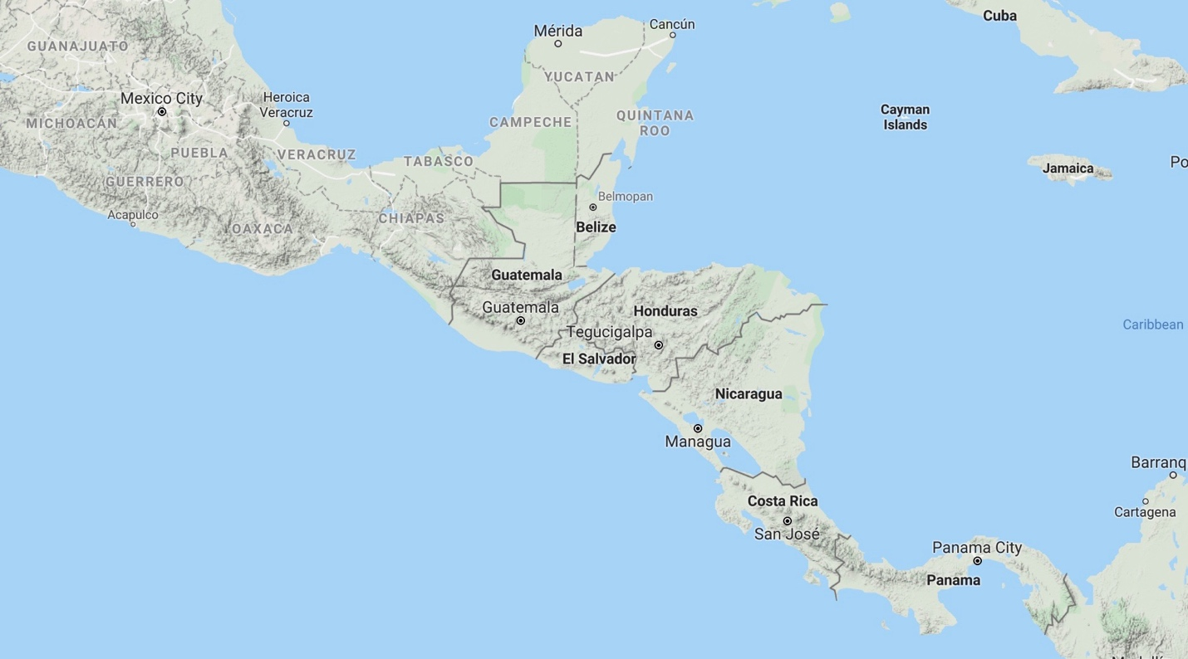

Illustration 2

Central American Immigrant Population in the United States, 1980-2019

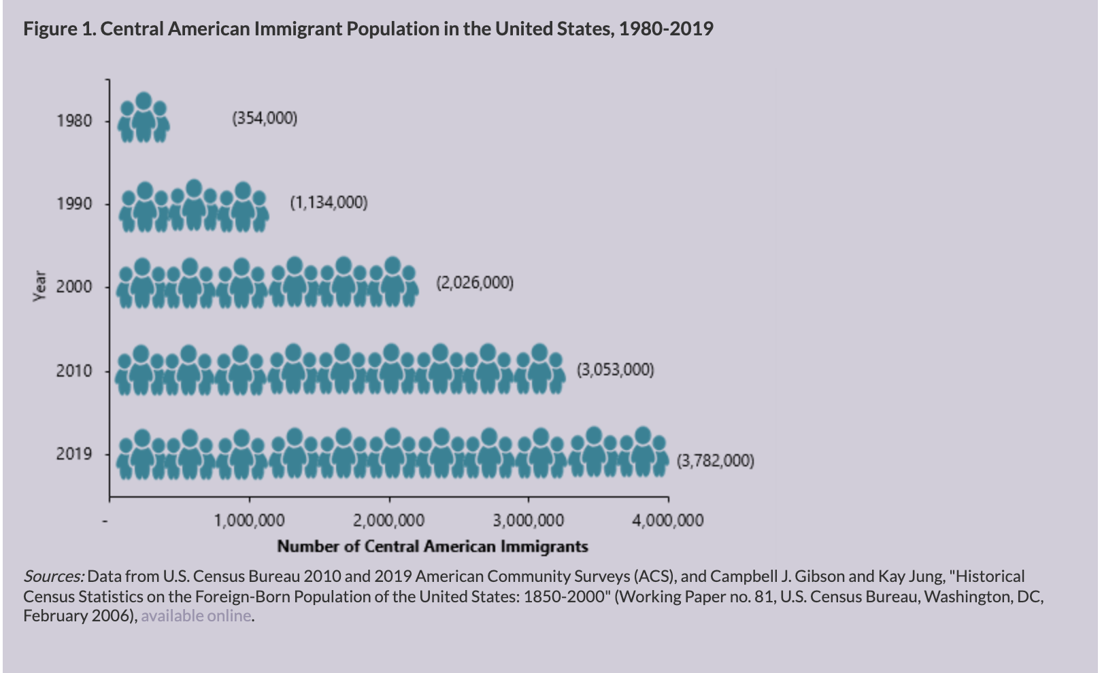
Source: Eric Babich and Jeanne Batalova,
“Central American Immigrants in the United States,” in Migration Policy Institute, August 11, 2021 (Washington DC, 2021): spotlight https://www.migrationpolicy.org/article/central-american-immigrants-united-states.

Illustration 3

“Northern Triangle” Central American migrants in the United States by country of origin

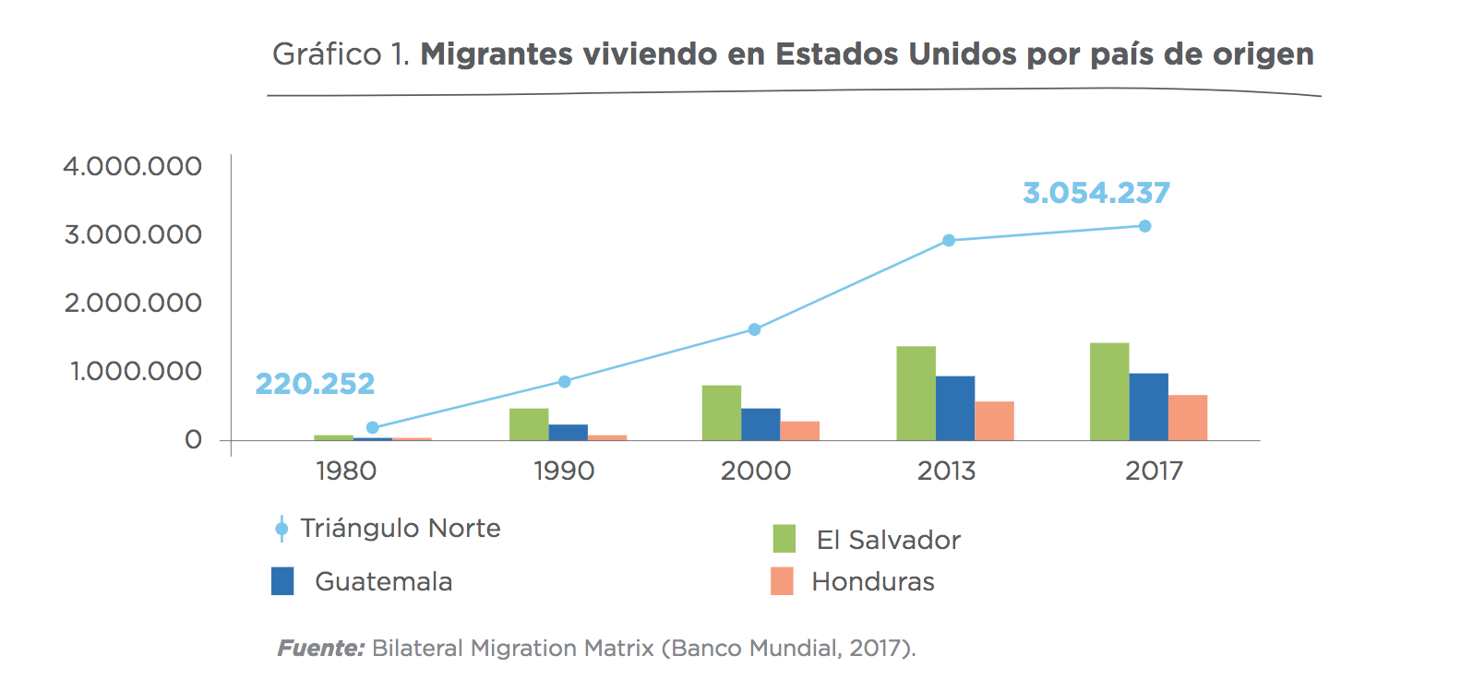
Source: Emmanuel Abuelafia, Giselle Del Carmen, Marta Ruiz-Arranz, “Tras los pasos del migrante: Perspectivas y experiencias de la migración de El Salvador, Guatemala y Honduras en Estados Unidos,” (New York: Inter-American Development Bank, December 2019), https://publications.iadb.org/publications/spanish/document/Tras_los_pasos_del_migrante_Perspectivas_y_experiencias_de_la_migraci%C3%B3n_de_El_Salvador_Guatemala_y_Honduras_en_Estados_Unidos.pdf.

Illustration 4

Suspected Maritime Drug Flow Events in 2016

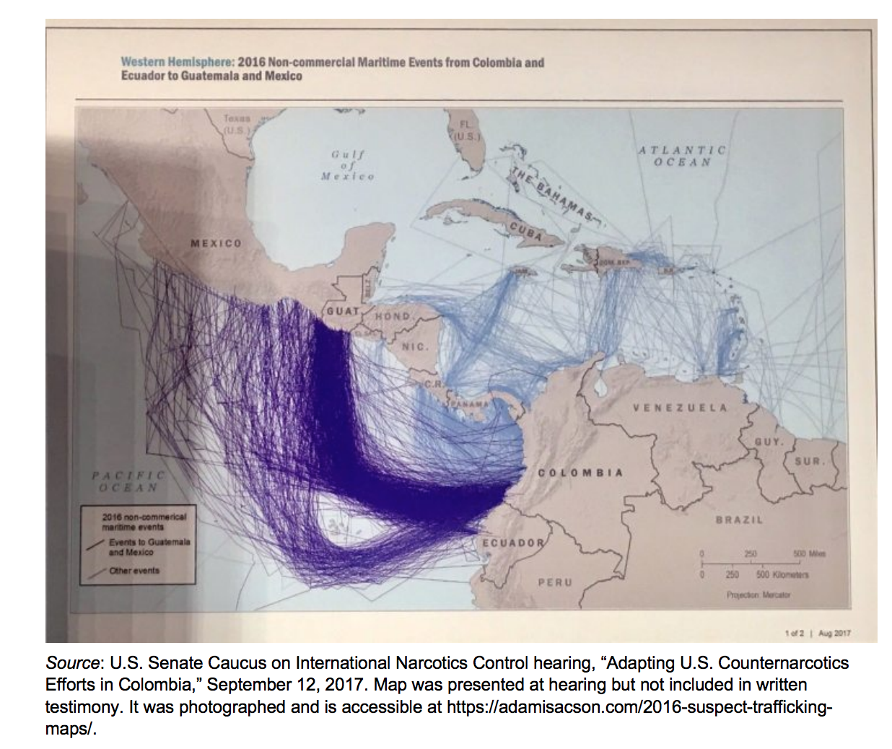

Source: National Center for Risk and Economic Analysis of Terrorism Events University of Southern California with Institute for Defense Analyses, “Northern Triangle Migrant Flow Study: Final Report September 30, 2018,” (California: University of Southern California, November 2018), 29, https://create.usc.edu/sites/default/files/northern_triangle_migrant_report.pdf.

Illustration 5

Maritime (red lines) and Aerial (yellow lines) of drug departures
toward Caribbean and Central America

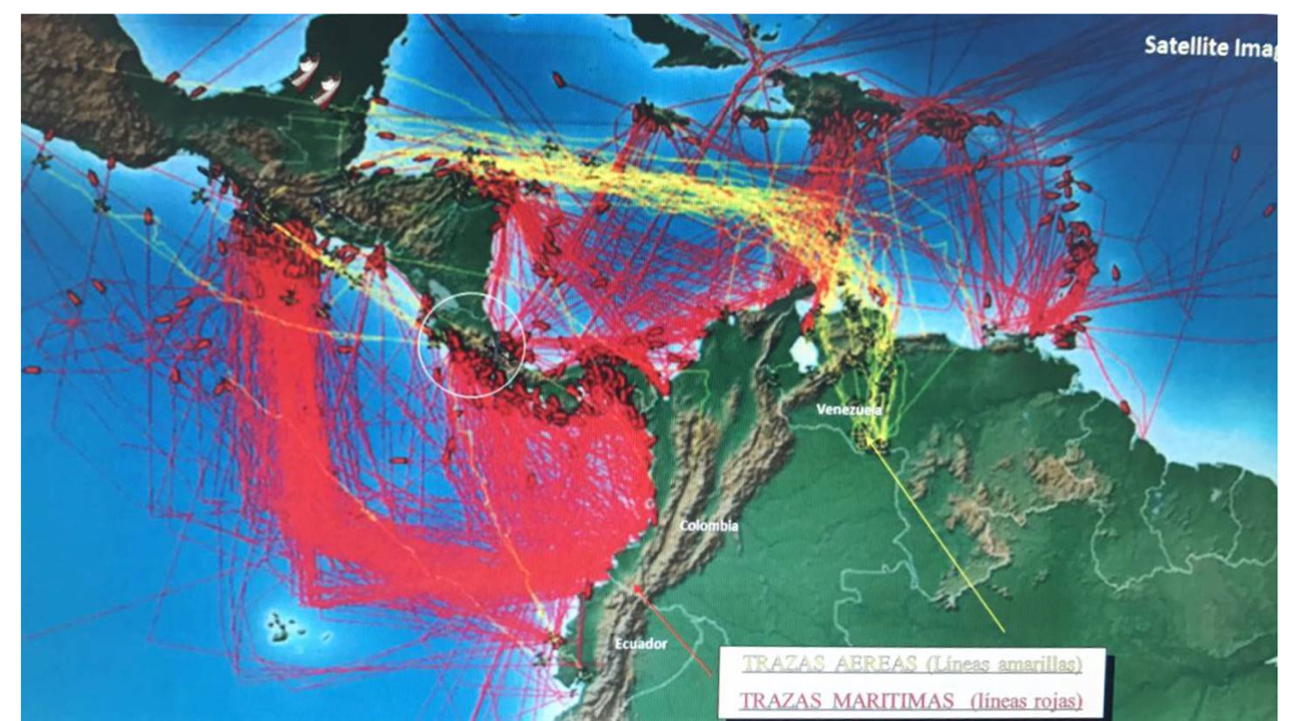

Source: Ministry of Security, Gustavo Mata, La Nación, 16 February 2017. See https://www.nacion.com/sucesos/narcotrafico/ministro-de-seguridad-no-hay-playa-en-costa-rica-donde-no-haya-penetrado-el-narco/LODR6JCJZVF7VDCWZX2IV7SDRY/story/

Illustration 6

Per Capita Income, Murder Rates, and Perceived Violence Indicators
(Average Values 2008-2016)

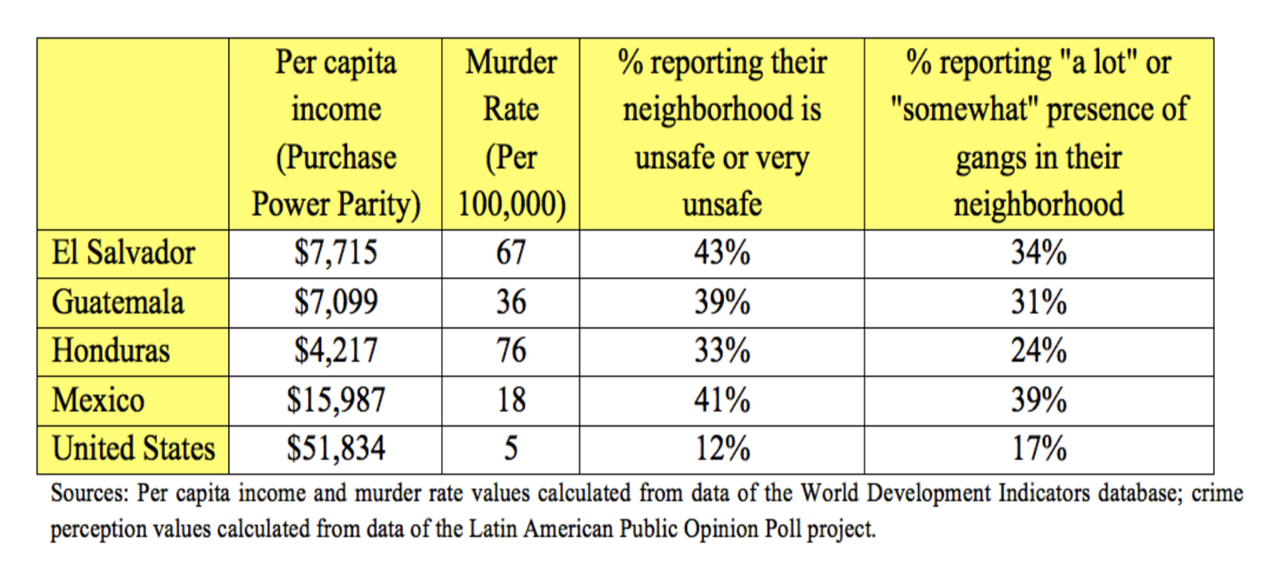
Source: CREATE, “Family Reunification and Economic Opportunities Bring “Northern Triangle” Immigrants to United States,” (California: University of Southern California, November 2018) https://create.usc.edu/study-examines-motivations-of-asylum-seekers-from-el-salvador-guatemala-and-honduras-to-the-united-states/

Illustration 7

Comparative Intentional Homicides with Mexico, USA, and Northern Triangle,
1995-2016
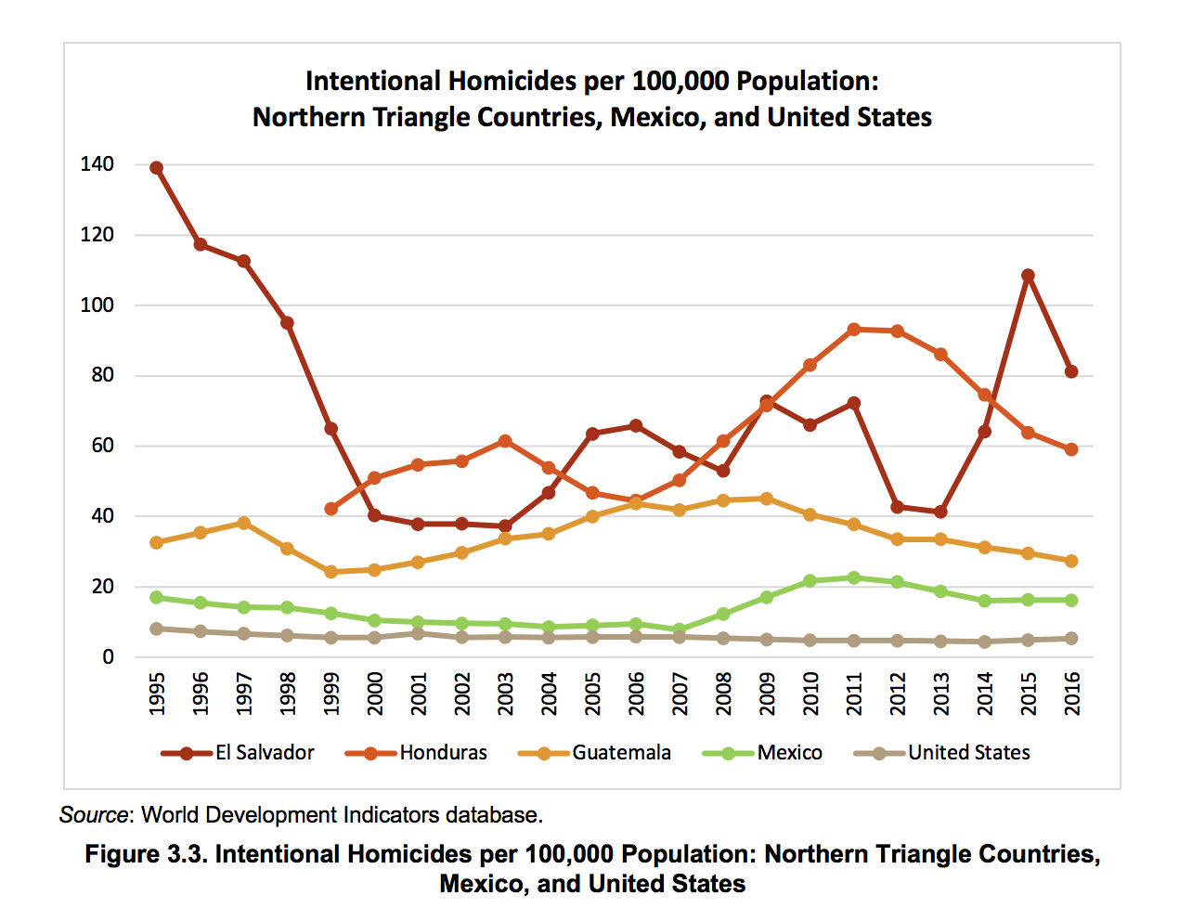

Source: National Center for Risk and Economic Analysis of Terrorism Events University of Southern California with Institute for Defense Analyses, “Northern Triangle Migrant Flow Study: Final Report September 30, 2018,” (California: University of Southern California, November 2018), 17, https://create.usc.edu/sites/default/files/northern_triangle_migrant_report.pdf.

Illustration 8

Central American homicide rates per 100,000 , 2020

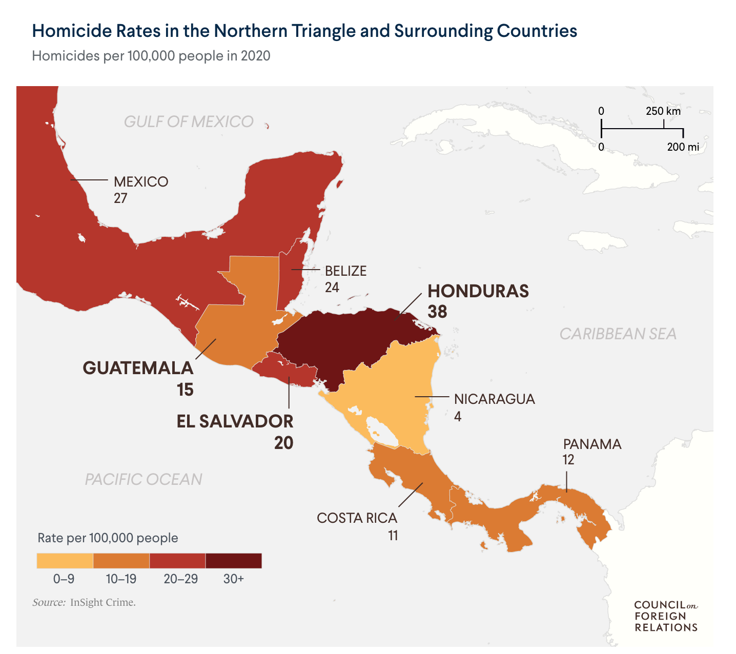
Amelia Cheatham, “Central America’s turbulent northern triangle,” Council on Foreign Relations, July 1, 2021,
https://www.cfr.org/backgrounder/central-americas-turbulent-northern-triangle

Illustration 9

Food Insecurity in the “Dry Corridor”

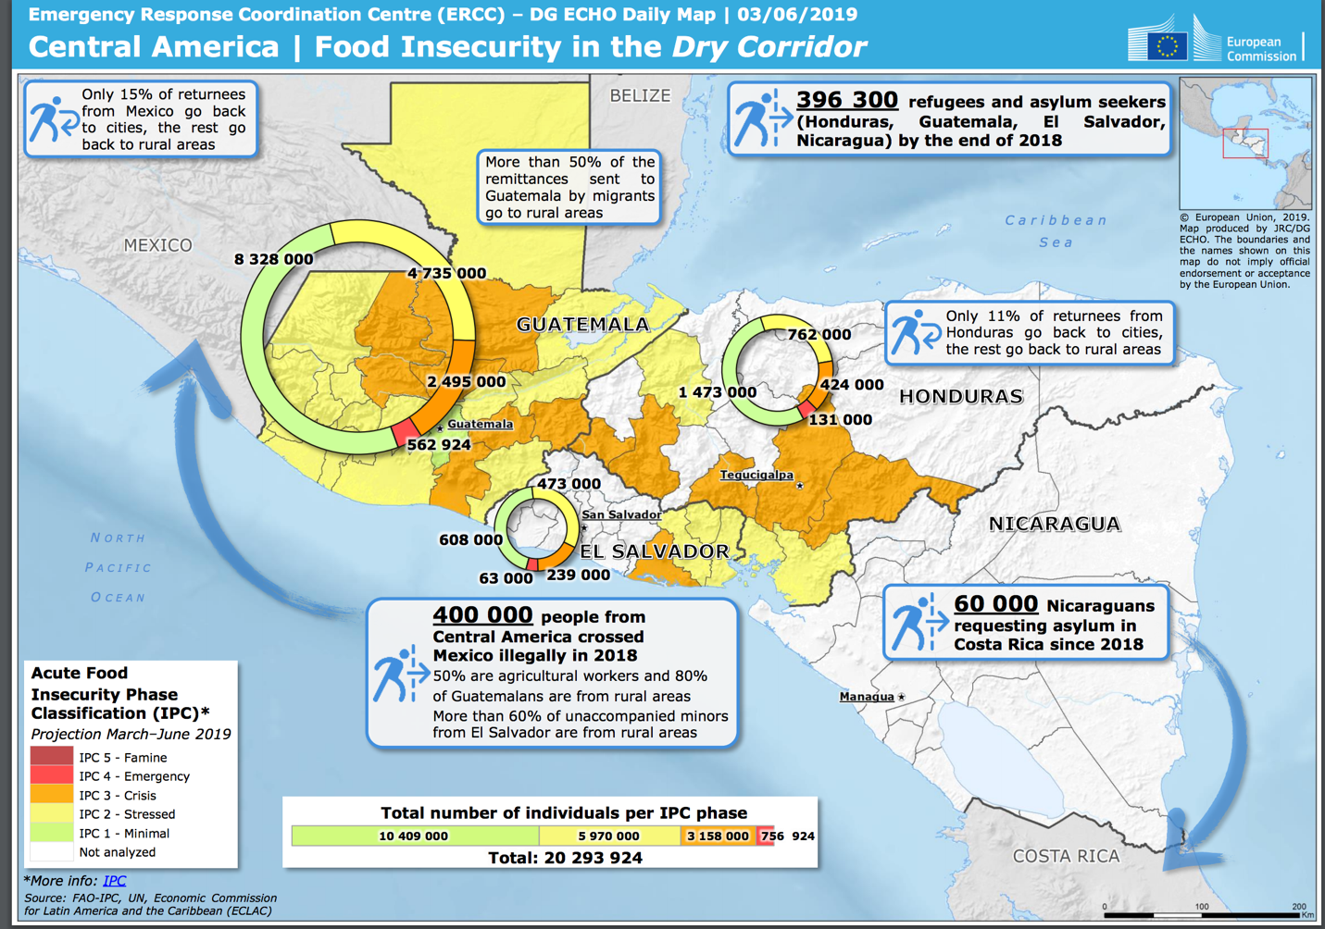

Source: from European Commission’s Directorate-General for European Civil Protection and Humanitarian Aid Operations (Belgium, June 3, 2019), (https://reliefweb.int/sites/reliefweb.int/files/resources/ECDM_20190603_Central-America_Food-Insecurity-2.pdf)

Illustration 10

Annual Remittance Flows to Central America, 1980-2018

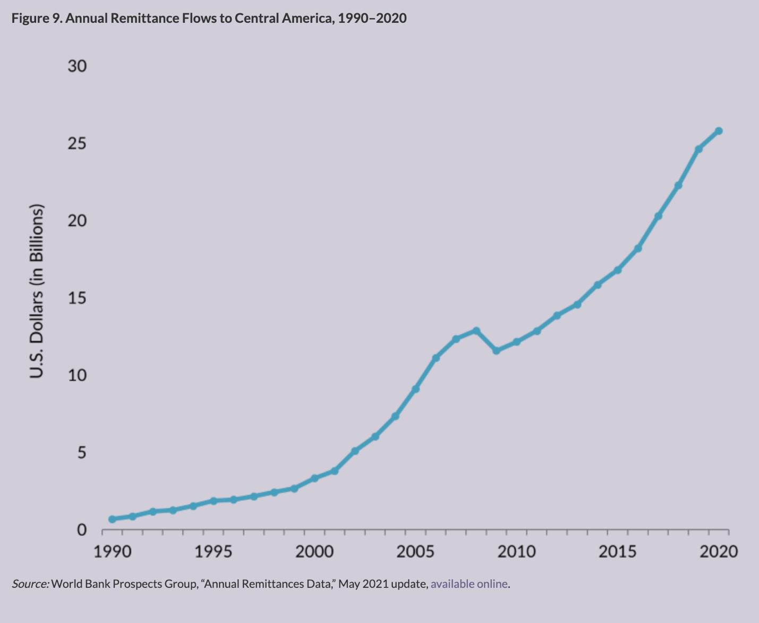

Source: Erica Babich and Jeanne Batalova,
“Central American Immigrants in the United States,” in Migration Policy Institute, August 11, 2021 (Washington DC, 2021): spotlight https://www.migrationpolicy.org/article/central-american-immigrants-united-states.

Illustration 11

Remittances as a share of GDP, Central America
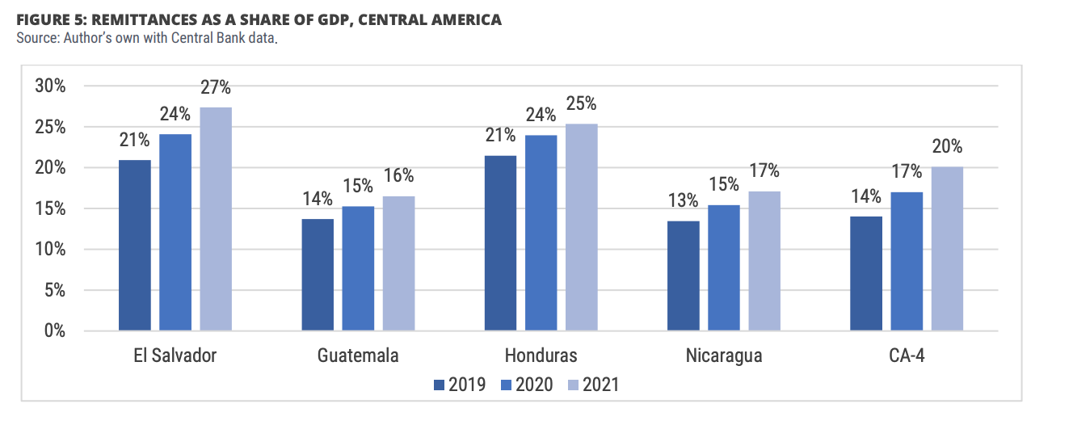

Source: Manuel Orozco and Kathryn Klaas, “A commitment to families: remittances and Covid-19 pandemic. Experience of US migrants,” Inter-American Dialogue and Creative Associates, Washington, DC, June 2021, 11. https://www.thedialogue.org/wp-content/uploads/2021/06/Survey-of-LAC-Migrants-2020-Report-Final.pdf

Illustration 12

Remittances to Central American Countries in 2018

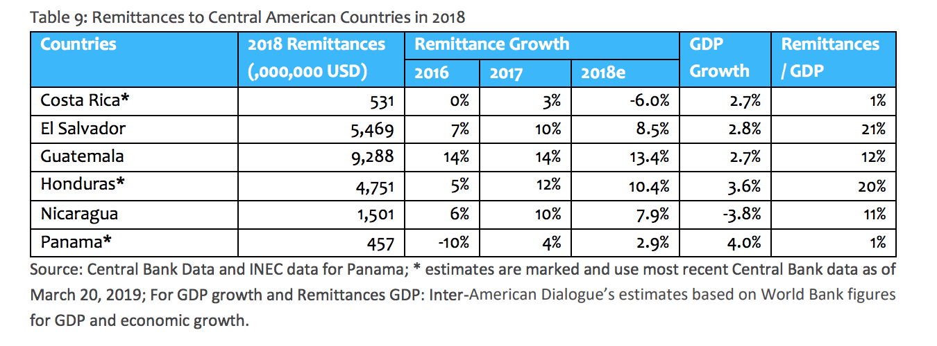
Source: Manuel Orozco Laura Porras Julia Yansura, “Remittances to Latin America and the Caribbean in 2018,” The Dialogue, 9, https://www.thedialogue.org/wp-content/uploads/2019/04/2018-NumbersRemittances.pdf.

Illustration 13

Poverty Rate (US $5.50 per day
2011 Purchasing Power Parity)
and
Youth aged 15 to 24 that do not study or work, 2017
(ALC: Latin America and Caribbean poverty rate)

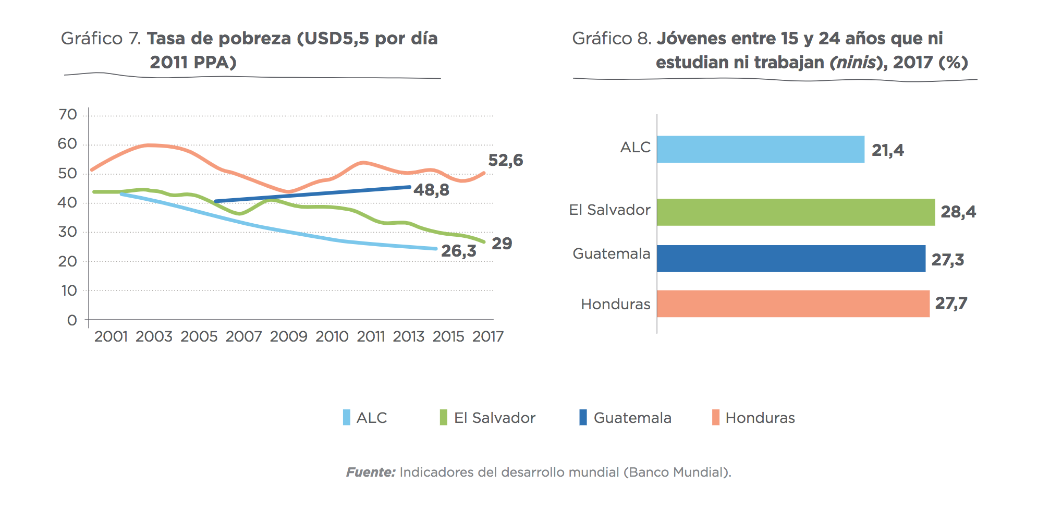
Source: Emmanuel Abuelafia, Giselle Del Carmen, Marta Ruiz-Arranz, “Tras los pasos del migrante: Perspectivas y experiencias de la migración de El Salvador, Guatemala y Honduras en Estados Unidos,” (New York: Inter-American Development Bank, December 2019), https://publications.iadb.org/publications/spanish/document/Tras_los_pasos_del_migrante_Perspectivas_y_experiencias_de_la_migraci%C3%B3n_de_El_Salvador_Guatemala_y_Honduras_en_Estados_Unidos.pdf.

Illustration 14

What are the “two main reasons” you left your country and
immigrated to the United States for the first time?
(Top two reasons in percentage)

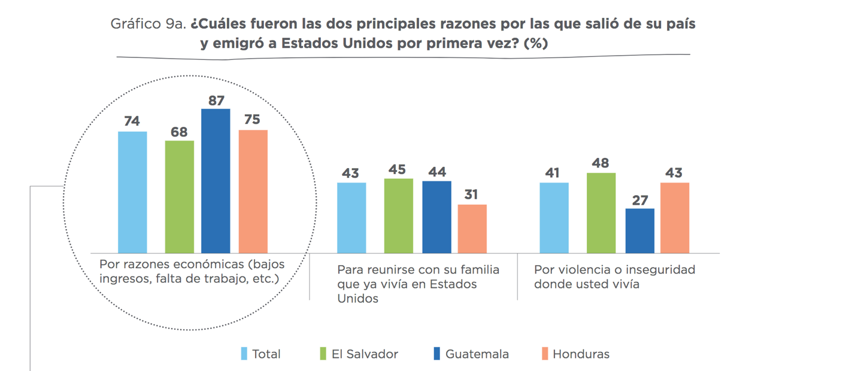

Translation: Circled Left block: For economic reasons (low income, lack of work, etc)
Middle block: To reunite with family that is already living in USA
Right block: To escape violence or insecurity where you live

Source: Emmanuel Abuelafia, Giselle Del Carmen, Marta Ruiz-Arranz, “Tras los pasos del migrante: Perspectivas y experiencias de la migración de El Salvador, Guatemala y Honduras en Estados Unidos,” (New York: Inter-American Development Bank, December 2019), https://publications.iadb.org/publications/spanish/document/Tras_los_pasos_del_migrante_Perspectivas_y_experiencias_de_la_migraci%C3%B3n_de_El_Salvador_Guatemala_y_Honduras_en_Estados_Unidos.pdf.

Section VI. Suggested Readings for futher study

Short of enrolling in a Central America history, political science or anthropology course, getting a sense of the depth and breadth of the key questions confronting our partners and Christian siblings through reading is quite the challenge. We will provide one or two key monographs for some of the questions that haunted us, and we encourage you to engage those monographs, and in particular, follow up on the key notes and bibliographical entries provided in each to further probe the questions that trouble you.

Political History of Central America

The Politics of Latin America: the power game, now in its 7th edition (2021), offers both a quick historic analysis of Latin America with a specific focus on ten countries in Latin America, including Guatemala and Nicaragua. The political scientists, Harry Vanden and Gary Prevost, examine case studies in each of these ten countries to analyze the evolution of power in the late 20th century and in the current dynamics till 2020.

If you prefer a narrative of the gripping stories that have emerged in this past historic decade, get a copy of the recent book (2017) by the Salvadoran journalist, Óscar Martínez, A history of violence: living and dying in Central America. Martínez made his mark with his first powerful analysis (2013) of the stories of the many Central Americans who attempted to travel on Mexico’s famous train on its eastern coast, entitled The Beast: Riding the Rails and Dodging Narcos on the Migrant Trail.

A strong current of understanding focuses on the overreach of imperial USA power in the region in the 20th and 21st century, and examines the external pressures on Central American actors who fight for dignity against the oppressive powers in the interwined histories of the USA and Central America. Professor Aviva Chomsky’s Central America’s forgotten history: revolution, violence and the roots of migration (2021) tackles these key questions in the drama of the Cold War and neo-liberalism’s quick evolution post peace agreements.

Understanding Religion, religiosity and the Church in Central America

Professor Robert Brenneman provides a look into the stories of former gang members who have joined an evangelical community in one of the three northern triangle countries. His Homies and Hermanos: God and gangs in Central America (2011) looks at the growing influence of Pentecostal faith in the region.

For a more historic look at the extraordinary alliance between faith and dictatorship, see Ginny Garrard’s Terror in the Land of the Holy Spirit: Guatemala under General Efraín Ríos Montt, 1982-1983, (2010) as she looks at the many threads of conflict within the evangelical, protestant and catholic communities that supported/opposed the dictatorship of General Ríos Montt during the insurrectionary decade of the 1980s and how the horrific violence against the Maya unfolded. Kevin O’Neil’s 2009 City of God: Christian citizenship in postwar Guatemala looks indepth into the character and nature of “neo-pentecostalism” surprising claims and sway.

Orbis Press (Maryknoll Order, NY) has consistently published ground-breaking works on the Catholic Church in Central America. The translated work of the theologian and Dominican priest, Gustavo Gutiérrez, A theology of liberation, was a crucial part of the transformation of the Catholic church in the 1970s and 1980s. The renowned Jesuit theologian, Jon Sobrino, who teaches and lives in El Salvador, puts his memories and gives witness to the martyr, the Archbishop Oscar Romero in Archbishop Romero: Memories and reflections (2016).

Competing visions for economic development in Central America

Professors Victor Bulmer-Thomas and A. Douglas Kincaid tackle the question of economic development propsects in Central America: towards a new regional developmental model (2020). Their recommendations are derived from “a conception of development that includes sustainable economic growth, improved social welfare and expanded citizenship.” Costa Rica, Guatemala and El Salvador far outpace Nicaragua and Honduras in per capita income and demonstrate scant prospect in closing that gap. See their recommendations and their bibliography for further conversations: http://ca2020.fiu.edu/documents_publications.html

Electronic Resources

To keep abreast current events unfolding, see recent publications by the WOLA, the Washington Office on Latin America (https://www.wola.org/program/central-america/). The best daily analysis of major headline stories emerging in Latin America is the Latin America Daily Briefing, edited by Jordana Timerman. The daily updated “blog” is a dispatch of news from Latin America and the Caribbean. See:
www.latinamericadailybriefing.blogspot.com.
Look into one of the first digital newspapers is El Salvador’s El Faro (The Lighthous), with an English translation of many of the key articles. See https://www.elfaro.net/

‘A Private Government in Honduras Moves Forward’ NACLA, Feb 15, 2021, https://nacla.org/news/2021/02/12/private-government-honduras-zede-prospera
“Fears for Democracy in El Salvador after President Claims to be ‘Coolest Dictator,’” The Guardian, 21 September 2021, https://www.theguardian.com/world/2021/sep/21/fears-for-democracy-in-el-salvador-after-president-claims-to-be-coolest-dictator).
In fact, the United States is a party to the 1967 Protocol, although it has never become a party to the 1951 Convention.
U.S. Citizenship and Immigration Services, Department of Homeland Security, “Continuation of Documentation for Beneficiaries of Temporary Protected Status Designations for El Salvador, Haiti, Nicaragua, Sudan, Honduras, and Nepal,” 10 September 2021.
Ladinos in Guatemala are people who speak Spanish and who have assimilated to Western lifeways. Many have both European and indigenous ancestry. The terms is to some degree interchangeable with mestizo.
Rev. Delia Leal has twice served as International Peacemaker to the PCUSA.
Jason Peña, “Most Nicaraguan Migrants Head South Instead of North,” Center for Immigration Studies, 3 October 2019, https://cis.org/Pena/Most-Nicaraguan-Migrants-Head-South-Instead-North. The article also provided this further context: “By contrast, in 2017 the U.S. Border Patrol apprehended only 1,721 Nicaraguans, and only 30 people were granted asylum. Despite its small size, next-door Costa Rica had, at least in 2017, a larger total number of Nicaraguans than the U.S. (including earlier migrants), about 294,000 vs. 276,000.”
Gisela Salomon, and Claudia Torrens. “With turmoil at home, more Nicaraguans flee to the U.S.,” AP News, 29 July 2021, https://apnews.com/article/joe-biden-religion-immigration-nicaragua-1495d0c1b3f7c5d166a4bb5407bb6860.
We met with Cairo Amador, one of the commissioners, and several of his team at the end of September 2019. The Comisión de la Verdad, Justicia y Paz—https://www.cvjp.org.ni/—was established in May 2018. Many international observers saw it as a farce (e.g., the statement of the executive director of the America’s Division of Human Right Watch—https://www.hrw.org/news/2018/05/14/nicaraguas-truth-commission-farce#), but we felt it important to hear their point of view. The OAS (Organization of American States) Assembly in June 2018 created its own commission, but this was denied entry by the Nicaraguan government.
The museum’s website—http://www.museodelamemorianicaragua.org/—non-commercial use of materials posted there and notes that in citations the entire name should be used: AMA y No Olvida, Museo de la Memoria Contra la Impunidad, 2019 (LOVE and Don’t Forget, Museum of Memory against Impunity, 2019).
We visited CENIDH on October 1st, and talked to their Executive Director. Some of their longstanding staff have fled to Costa Rica and joined the “Nunca Más” (Never More) movement there, while, at the time of our visit, nineteen were continuing their documentation of human-rights violations in Nicaragua. They, too, have received support and space from UCA.
The economic crisis is profound. US Embassy representativesconcurred that Ortega had been pro-business for years, leading the US to take a “live and let live” policy. They also reported to us that the Nicaraguan economy had now been in decline for six quarters. Juan Sebastian Chamorro, economist and head of the Civic Alliance, reported to us that, since April 2018, bank deposits were down 35 percent, bank credit was highly restricted, and the exchange-rate way down. Both tourism and construction, he told us, had declined almost to zero, nearly half a million people had lost their jobs, and new government-imposed taxes on food had made eating an unaffordable luxury, leaving many in dire poverty. See also Selser, Gabriela, “Business group: Nicaragua’s economy in ‘free fall’,” AP News, 24 April 2019, https://apnews.com/929fd26244e54b478ce6ffb7b23f5ba6.
Figures from 2017 put the population’s religious affiliation at 50% Catholic and 33% Protestant. (That latter is listed as “Evangelical” – a word which has a wider meaning in Latin America than in the US, encompassing all Protestants.) https://www.cia.gov/library/publications/the-world-factbook/geos/nu.html
Selser, Gabriela, “Nicaragua files weapons charges against opposition activists,” AP News, November 18, 2019, https://apnews.com/0bbe9d8ab5fd440d8c3bfe555998232a
Ibid.
Matthew Schwartz, “How the Trump Cabinet’s Bible Teacher Became a Shadow Diplomat,” New York Times Magazine, 29 October 2019, https://www.nytimes.com/2019/10/29/magazine/ralph-drollinger-white-house-evangelical.html.
Rodriguez, Sebastian, “Despite drought, Costa Rica's electricity stays clean - but not cheap,” June 19, 2019, https://www.reuters.com/article/us-costa-rica-electricity-drought-analys/despite-drought-costa-ricas-electricity-stays-clean-but-not-cheap-idUSKCN1TK1VZ
CIA Factbook figures for 2016 are Roman Catholic 71.8 percent, Evangelical and Pentecostal 12.3 percent, other Protestant 2.6 percent, Jehovah's Witness 0.5 percent, other 2.4 percent, none 10.4 percent (https://www.cia.gov/the-world-factbook/countries/costa-rica/#people-and-society)—but our conversations at UBL suggest that the shift to Protestantism may be higher than these numbers indicate.
Esquivel, Julia, and Anne Woehrle. 2003, They Have Threatened Us with Resurrection. Spiritus: A Journal of Christian Spirituality 3(1): 96-101. doi:10.1353/scs.2003.0009.
https://www.epdc.org/epdc-data-points/violence-threatens-educational-gains-central-america. See also: https://tellmaps.com/uis/literacy/#!/tellmap/-601865091
United Nations, “Global Study on Homicide,” 2019, https://dataunodc.un.org/GSH_app.
The seven countries in the Central American region (Belize, Costa Rica, El Salvador, Guatemala, Honduras, Nicaragua, and Panama) have a combined land area 202,230 square miles, which is roughly the combined area of the states of Colorado and Wyoming (with the addition of Rhode Island). In 2016, the estimated population of the region was 44.5 million, and the population density was 210 people/square mile. This compares generally to the states of Virginia and North Carolina in the US. Because of historical differences and the historical lack of church partners in Belize and Panama, this report is focused on the contemporary sociopolitical situation in Costa Rica, El Salvador, Guatemala, Honduras, and Nicaragua. As noted earlier, these countries were the focus of PCUSA attention during a time of revolutionary ferment in the 1980s, and limiting our study to these five enables us to preserve historical continuity while drawing attention to the interconnections between Central America and the United States that persist into the present.
Manuel Orozco, 2019, Trends in Migration, Remittances, Markets and Development to Latin America and the Caribbean, The Dialogue, https://www.thedialogue.org/wp-content/uploads/2019/10/Future-Trends-In-Migration.pdf. See Appendix
Gene Palumbo and Elisabeth Malkin, 2017, El Salvador, Prizing Water Over Gold, Bans All Metal Mining, 29 March, https://www.nytimes.com/2017/03/29/world/americas/el-salvador-prizing-water-over-gold-bans-all-metal-mining.html. Concern was raised in at least one interview setting over whether the ban would be upheld over time.
Global Witness, Last Line of Defence. The industries causing the climate crisis and attacks against land and enivornmental defenders. England: September 2021, 10.

